Brandon Gray

Stat 447

4/21/12

Stat 447 Mount Modeling

**Problem Statement:**

The goal of this project is to create a linear model using a sample wind tunnel test. From here, the error of the model will be studied. Because the mount used to test was not truly rigid, the mount produced unwanted noise that added an additional error to the measurement. If the error from the mount can be removed, this would allow for higher confidence in the measurements taken. This also will be useful for future tests that will most certainly be run using the same or a similar mount configuration.

**This is far too vague.**

**A linear model of what?**

**How does a non-rigid mount produce noise?**

**High confidence in the measurements? Numbers do not have confidence. It is their estimators that have confidence.**

**You need to first include an Introduction section that describes the physical system that you are addressing, and what you hope to learn about it. Some references to similar work are appropriate, as well. Pictures are worth 1000 words here. ☺**

**In section 2 (Problem Statement) first, describe in words the problem you are addressing. It may be helpful to include some plots of data to aid the discussion.**

**Next, give appropriate equations related to the problem statement. These can include force and moment equations, as well as equations that relate forces to aerodynamic parameters of interest (e.g. the lift coefficient). Here, you will need to distinguish between static and dynamic equations.**

**Third, address the random variables that refer to static equations, and the random processes that relate to dynamical equations. For example, for a static variable, X, the time-indexed collection (X1, … , Xn) may be viewed as the associated data collection variables. This view amounts to assuming that each Xk has the same pdf as X. It does NOT assume that they are mutually independent. In general, they will not be.**

**Experimental Measurements:**

The wind tunnel results used for this examination were obtained using a JR-3 high accuracy, 6 degree of freedom force sensor while testing a rapid prototyped model airplane. Testing was performed in the AABL wind tunnel at Iowa State University during the fall of 2011.

The variable of interest measured during the experiment was the lift force of the model. This was the largest force measured and contained the greatest amount of noise from the mount. The JR-3 was connected to the model and then connected to the mount using an aluminum rod wrapped in carbon fiber. The measurement axes are shown below, as seen when looking at the incoming flow. FZ was out of the page, where into the page represents flow down the tunnel

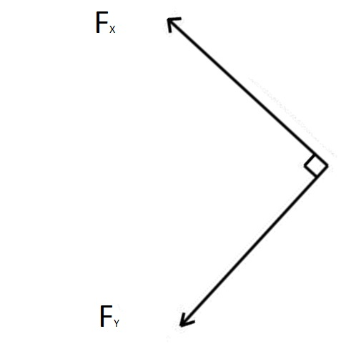

The measurement variables are noted below:

XK = the act of measuring the kth JR-3 force FX in lbs while running a wind tunnel test. $\vec{X}=(X_{1},X_{2},X_{3},…,X_{10,000})$ where the JR-3 measured forces with double precision from -15 to 15 **lbs This is confusing notation since it appears that Xk is a data collection variable associated with the generic random variable FX. Not a good idea ☹**

YK = the act of measuring the kth JR-3 force FY in lbs while running a wind tunnel test. $\vec{Y}=(Y_{1},Y_{2},Y_{3},…,Y_{10,000})$ where the JR-3 measured forces with double precision from -15 to 15 lbs

The linear model will be set up using the following:

$$x_{t+1}=a_{1}x_{t}+a_{2}x_{t-1}+∈_{t}$$

where $∈_{t}$ is the mount noise that will be studied more in depth.

**Where did the justification for the above linear model come from? It would appear that it is arbitrary.**

The following two figures show the 50 bin histograms for FX and FY

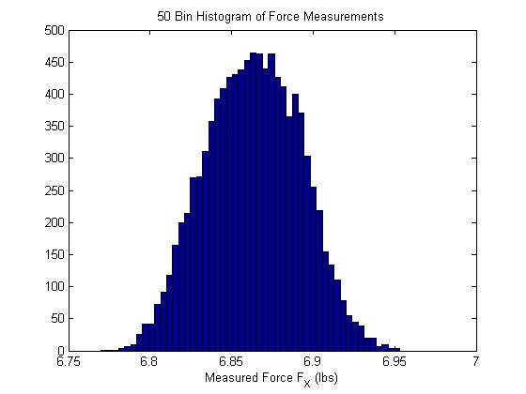

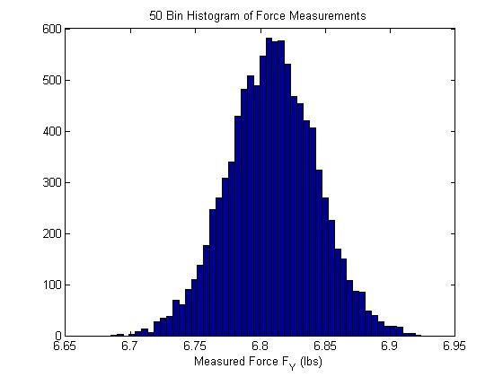

**Figure 1. Describe the figures. 🡨 This is essential for ANY report.**

**Here, you are assuming that the data collection variables are replicates of X (i.e. FX). Some justification for this is needed. For example a simple plot of the x-data times series would help. If the data appears to behave in a ‘stationary’ way (i.e. oscillating about a constant value, and having oscillation structure that appears the same wherever you look), then that is enough to assume they are replicates of X.**

**This needs to be done BEFORE the above figure. Also, it is better to scale these so that they are pdf’s. You might also overlay normal models with specified means and std. deviations.**

As can be seen above, both of the force measurements seem to be distributed normally. The mean of FX is about 6.86 and the mean for FY is about 6.81, leading me to believe that either the model or the force sensor was not oriented at exactly the 45 degree offset, or the mount was adding noise to the system, throwing off the measurements slightly. Also, in the second histogram, the FY lower tail can be seen going all the way below 6.7 lbs, while the FX histogram has a minimum measurement at about 6.77 lbs.

**Some good observations. But WHY should the estimated pdfs for X and Y be the same?**

**More fundamentally: ARE THE TRUE PDF’s THE SAME???**

Finally, we take a look at the autocorrelation of the measurement. The figures for these are shown below for 9900 lags. The autocorr function in matlab performs a de-meaned sample autocorrelation on the measurements.

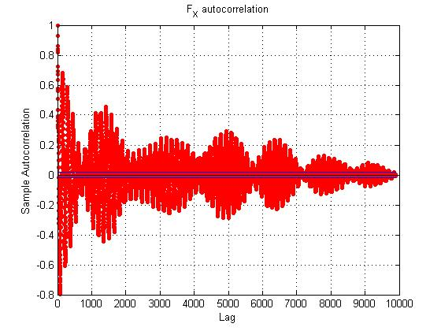

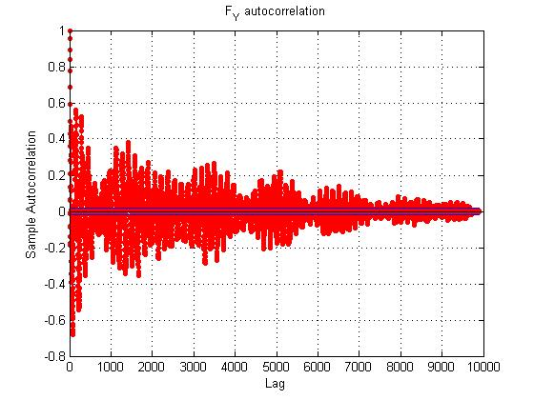

It can be seen that the tendencies are similar, but when you take a look on a smaller scale, you quickly notice that they are not so alike. Below is a 100 lag autocorrelation of the same measurements.

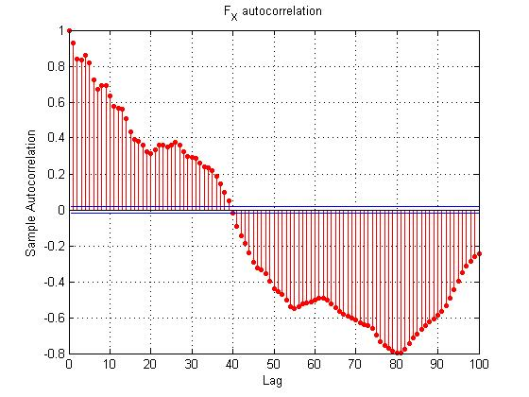

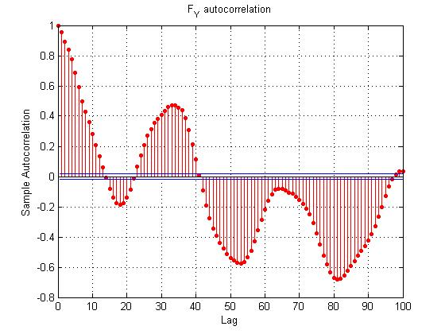

**Figure 2. Describe (a) … (b)… (c)…. (d)…**

It is very easy to look at these images and see the differences. They both have a minimum at about the 80 lag point, but the overall pictures are completely different.

**Even though these are estimates of the autocovariance function (not the autocorrelation function, I would agree- it is very likely that the true autocovariance functions ARE different from one another**

**QUESTIONS RELATED TO AUTOCOVARIANCES:**

**Q1: What is your sampling interval? You are sampling at a VERY high rate!**

**Q2: How many lags (m) are needed to assume that Xk and Xk+m are uncorrelated?**

**Q3: Did you use a biased or an unbiased estimator of Cov(Xk , Xk+m) = C(m) ? It is essential that you give the equations for estimators of ALL important quantities. It is my guess that you used the biased estimator.**

**Q4: What happened to the AR/MV analysis???**

**Q5: Are the true means and variances of X and Y equal or not equal? (Hyp. test) This test will not be exactly like those in the homework because your data collection variables are correlated.**

**In conclusion: You have a ways to go.**