Introduction and Overview of Course Concepts

In this set of notes we will use a summary of a published research study to convey the main concepts that will be covered in this course.

Common weed killer turns male frogs into females
Maggie Fox, Health and Science Editor, Reuters March 2, 2010, 7:43 am
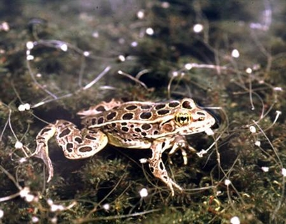
WASHINGTON (Reuters) - Atrazine, one of the most commonly used and controversial weedkillers, can turn male frogs into females, researchers reported on Monday. The experiment is the first to show such complete effects of atrazine, which had been known to disrupt hormones and which is one of the chief suspects in the decline of amphibians such as frogs around the world. "Atrazine-exposed males were both demasculinized (chemically castrated) and completely feminized as adults,"
Tyrone Hayes of the University of California Berkeley and colleagues wrote in the Proceedings of the National Academy of Sciences. The chemical had been shown to disrupt development and make frogs develop both male and female features -- termed herma-phroditism. This study of 40 male frogs shows the process can go even further, Hayes said. "Before, we knew we got fewer males than we should have, and we got hermaphrodites. Now, we have clearly shown that many of these animals are sex-reversed males," Hayes said in a statement. "Atrazine has caused a hormonal imbalance that has made them develop into the wrong sex, in terms of their genetic constitution."
SIMILAR EFFECTS ON HUMANS?
Whether the effects translate to humans is far from clear. Frogs have thin skin that can absorb chemicals easily and they literally bathe in the polluted water. The European Union banned atrazine in 2004. The finding may add pressure to the United States to more closely regulate the chemical, used widely in agriculture. "Approximately 80 million pounds (36,287 tonnes) are applied annually in the United States alone, and atrazine is the most common pesticide contaminant of ground and surface water," the researchers wrote. "Atrazine can be transported more than 1,000 km (621 miles) from the point of application via rainfall and, as a result, contaminates otherwise pristine habitats, even in remote areas where it is not used," they added, citing other researchers. "In fact, more than a half million pounds (227 tonnes) of atrazine are precipitated in rainfall each year in the United States." The U.S. Environmental Protection Agency said in October it was reviewing the health impacts of atrazine.
Syngenta AG, one of several companies that makes atrazine, has long defended its safety. The company says it is one of the best-studied herbicides available and pointed to prior safety reviews from the EPA and World Health Organization, among others. Hayes and colleagues studied 40 African clawed frogs, keeping them in water contaminated with 2.5 ppb (parts per billion) of atrazine. The EPA's current drinking water standard is 3 ppb. "Ten percent of the exposed genetic males developed into functional females that copulated with unexposed males and produced viable eggs," the researchers wrote. "Regardless of the mechanism, the impacts of atrazine on amphibians and on wildlife in general are potentially devastating," they wrote. "The negative impacts on wild amphibians is especially concerning given that the dose examined here (2.5 ppb) is in the range that animals experience year-round in areas where atrazine is used as well within levels found in rainfall, in which levels can exceed 100 ppb in the Midwestern United States," they added. □
Q1: In words, what was the goal of the study?
A1:

Q2: What would be a probabilistic formulation of this goal, using mathematical symbols?
A2:

Q3:In words, what was the procedure that was used to achieve the goal of the study?
A3:

Q4: What would the description of the procedure using mathematical symbols?
A4:

Q5: What assumptions are being made in relation to the symbols?
A5:

Q6: What would have made the study more conclusive (i.e. trustworthy)?
A6:

