Notes on Confidence Interval Estimation
by
Peter Sherman

Confidence intervals are used routinely to provide information pertaining to the range of possible values for unknown statistical parameters. Commonly involved parameters include the mean, standard deviation for a normally distributed variable, and the proportion for a Bernoulli variable. The results reported are numerical ranges that a parameter might be expected to fall in a certain percentage of the time. However, the following definition indicates that a (1-α)-% confidence interval (CI) is, in fact a random end point interval, and not a numerical interval.

Definition 1. Suppose ${\left\{X_{k}\right\}}_{k=1}^{n}$ are i.i.d. with a parameter $θ$. Let $\hat{θ}$ be an estimator of $θ$. Then a (1-α)-% CI for $θ$ is obtained as follows:

Step 1: Set 1-α = Pr[$β_{1}<\hat{θ}<β_{2}]$.

Step 2: Select a functional relationship $g(θ,\hat{θ})=W$where the random variable W has a known, standardized distribution

Step 3: Using equivalent events, write 1-α = Pr[$w_{1}<g(θ,\hat{θ})<w_{2}]$ and find the numerical values of $w_{1},w_{2}$ so that the probability α outside of this interval is evenly split to either side of it.

Step 4: Use algebraic manipulation of equivalent events to arrive at an event where $θ$ is retained between two endpoints, which must be random endpoints, since they must involve $\hat{θ}$. This random endpoint interval is called the (1-α)-% CI for $θ$.

When a measurement of $\hat{θ}$ is used, the resulting numerical interval is often termed an estimated CI, to distinguish it from the random endpoint CI. The probabilistic nature of a CI suggests that, were one to repeatedly obtain estimated CIs, that approximately (1-α)-% of them would contain the unknown parameter, $θ$. The following example illustrates this interpretation.

Example. Assume that ${\left\{X_{k}\right\}}_{k=1}^{n}$ are i.i.d. ~ N($(μ,σ^{2})$. In this example, we will use $n=\text{20}, μ=\text{10}, σ=2$ and $α=0\text{.}1$

(a) Computation of a (1-α)-% CI for $μ$ when $σ$is known:

$1−α=\text{Pr}[z_{1}<\frac{\hat{μ}−μ}{σ/{\sqrt{n}}}<z_{2}]=\text{Pr}[\hat{μ}+σ/{\sqrt{n}}z_{1}<μ<\hat{μ}+σ/{\sqrt{n}}z_{2}]$. (1)

Hence, the (1-α)-% 2-sided CI for $μ$ is $[\hat{μ}+σ/{\sqrt{n}}z_{1},\hat{μ}+σ/{\sqrt{n}}z_{2}]$ where $z_{2}=1\text{.}\text{64} (z_{1}=−z_{2})$. Fifty estimated CIs are shown in Figure 1. Of these, we see that 4 of them do not contain $μ=\text{10}$. This represents 8% of them; which is close to the expected 10% were one to repeat the experiment long enough.

(b) Computation of a (1-α)-% CI for $μ$ when $σ$is unknown:

Let ${\hat{σ}}^{2}$ be the usual estimator of $σ^{2}$. Then, it turns out that

$1−α=\text{Pr}[t_{1}<T_{n}=\frac{\hat{μ}−μ}{{\hat{σ}}/{\sqrt{n}}}<t_{2}]=\text{Pr}[\hat{μ}+{\hat{σ}}/{\sqrt{n}}t_{1}<μ<\hat{μ}+{\hat{σ}}/{\sqrt{n}}t_{2}]$ (2)

where $T_{n=\text{20}}$ has a t-distribution, with t-values $t_{2}=1\text{.}\text{72}, (t_{1}=−t_{2})$. We see that $t_{2}=1\text{.}\text{72}$ is only slightly larger than $z_{2}=1\text{.}\text{64}$, so that one should expect the results in Figure 2 to be similar to those in Figure 1. Notice that the interval widths in Figure 1 are constant, while those in Figure 2 vary over the simulations.

(c) Computation of a (1-α)-% CI for $σ$ when $μ$ is known and CLT is assumed to hold:
Even though n=20 is not very large, often people will still assume it is large enough to invoke the Central Limit Theorem. Since the mean and variance of ${\hat{σ}}^{2}$can be shown to be $σ^{2}$and $2{σ^{4}}/n$, respectively, the approach in (1) gives

$1−α=\text{Pr}[z_{1}<\frac{{\hat{σ}}^{2}−σ^{2}}{{σ^{2}}/{\sqrt{2/n}}}<z_{2}]=\text{Pr}[\frac{{\hat{σ}}^{2}}{1+z_{2}\sqrt{2/n}}<σ^{2}<\frac{{\hat{σ}}^{2}}{1+z_{1}\sqrt{2/n}}]$ (3)

The results for this CI are shown in Figure 3. We see that 7 of the 50 simulations do not contain $σ=2$ , and, moreover, that they are all lower than this value. Thus, it is being underestimated; it is actually larger than we are being led to believe, based on the normal assumption. This makes sense, in view of the fact that for small n, our variabilirty should be greater than that associated with the normal approximation.

(d) Computation of a (1-α)-% CI for $σ$ when $μ$ is known and CLT is not assumed to hold:
It is well known that $n{{\hat{σ}}^{2}}/{σ^{2}}$ ~ $χ_{n}^{2}$ so that we arrive at

$1−α=\text{Pr}[\hat{σ}\sqrt{n/{x_{2}}}<σ<{\hat{σ}}^{2}\sqrt{n/{x_{1}}}]$ where $x_{1}=\text{10}\text{.}\text{85}$ and $x_{2}=\text{31}\text{.}\text{41}$

The results are shown in figure 4.

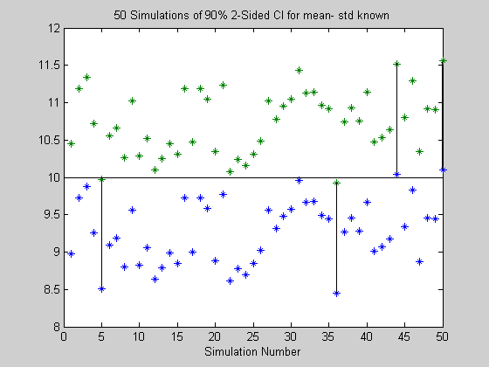
Figure 1. Estimated CIs for μ, assuming σ known

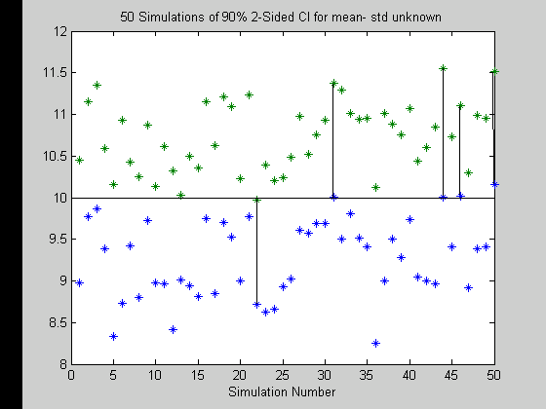
Figure 2. Estimated Cis for μ, assuming σ unknown

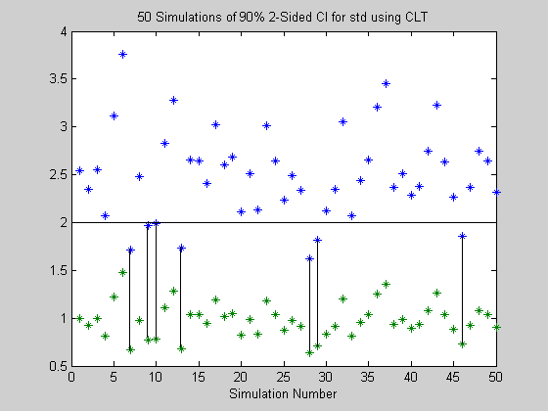
Figure 3. Estimated CIs for σ assuming n is large enough for normal approximation.

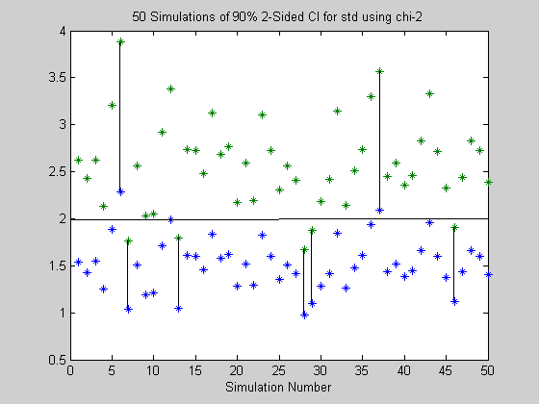
Figure 4. . Estimated CIs for σ assuming n is not large enough for normal approximation
%PROGRAM_NAME: CI.m
% This program is for Fall 2001 STAT 330 CI estimation
% Generate n=20 x m=50 array of N(10,4) samples
n=20; %number of measurements of X
m=50; %number of simulations
Xmat=2*randn(n,m) + 10;
Xbar=mean(Xmat);
Xstd1=2; %assumes std is known
Xstd2=std(Xmat); % assumes std is not known
z=1.64; %z-value for 90 percent CI
%COMPUTE CIs for MEAN
c1=z*Xstd1/(n^0.5);
CI1=[Xbar-c1 ; Xbar+c1]; %CIs for std known
t=1.72; %t-value for n=20 and 90 percent CI
c2=t*Xstd2/(n^0.5);
CI2=[Xbar-c2 ; Xbar + c2]; %CIs for std unknown
%COMPUTE CIs for STD
c3=(1+1.64*(2/n^0.5))^-0.5;
c4=(1-1.64*(2/n^0.5))^-0.5;
CI3=[Xstd2/c3 ; Xstd2/c4]; %CI for std using normal approx
c5=(n/31.41)^0.5;
c6=(n/10.85)^0.5;
CI4=[c5*Xstd2 ; c6*Xstd2];
%PLOT RESULTS
sim=1:1:50;
figure(1)
plot(sim,CI1,'*')
xlabel('Simulation Number')
title('50 Simulations of 90% 2-Sided CI for mean- std known')
pause
figure(2)
plot(sim,CI2,'*')
xlabel('Simulation Number')
title('50 Simulations of 90% 2-Sided CI for mean- std unknown')
pause
figure(3)
plot(sim,CI3,'*')
xlabel('Simulation Number')
title('50 Simulations of 90% 2-Sided CI for std using CLT')
pause
figure(4)
plot(sim,CI4,'*')
xlabel('Simulation Number')
title('50 Simulations of 90% 2-Sided CI for std using chi-2')

