More Food for Thought re: ANOVA CONCEPTS

Classic ONE-WAY DESIGN
$\underline{X}=[X_{1},…,X_{m}]^{\text{tr}}\text{\sim }N({\underline{μ}}_{X},σ_{X}^{2}I)$ (1a)
${\underline{μ}}_{X}=μ+\underline{α}=μ+[α_{1},…,α_{m}]^{\text{tr}}$. (1b)

PROBLEM: Test $H_{o}:\underline{α}=\underline{0} \text{versus} H_{1}:\underline{α}≠\underline{0}$.

SOLUTION (ANOVA): Define the m-D ERROR random variable:

$\underset{\text{\sim }}{ε} \overset{Δ}{=} \underset{\text{\sim }}{X} − {\underset{\text{\sim }}{μ}}_{X}$ (2a)

$E(\underline{ε})=\underline{0} \text{and} \text{Cov}(\underline{ε})=σ_{X}^{2} Ι$. (2b).

THEOREM 1. Suppose ${\left\{{\underline{X}}_{k}\right\}}_{k=1}^{n} \text{\sim } \text{iid} f_{\underline{X}}(\underline{x})$, and define $\underline{x}∈ℜ^{m}, {\left\|\underline{x}\right\|}^{2}={\underline{x}}^{\text{tr}}\underline{x}=\sum_{k=1}^{m}{x_{k}^{2}}$

Then $E{\left\|\underline{X}−μ\underline{1}\right\|}^{2}=E{\left\|\underline{ε}\right\|}^{2}+{\left\|\underline{α}\right\|}^{2}$ (3)

Proof:
$$E\left\|\underline{X}−μ\underline{1}\right\|=E{\left\|\underline{X}−(μ\underline{1}+\underline{α})−\underline{α}\right\|}^{2}=E{\left\|\underline{ε}−\underline{α}\right\|}^{2}=E[(\underline{ε}−\underline{α})^{\text{tr}}(\underline{ε}−\underline{α})]$$
$=E{\left\|\underline{ε}\right\|}^{2}+2{\underline{α}}^{\text{tr}}E(\underline{ε})+{\left\|\underline{α}\right\|}^{2}=E{\left\|\underline{ε}\right\|}^{2}+{\left\|\underline{α}\right\|}^{2}$▄
Some Questions:

Q1. How to handle the case where under Ho the means are not equal?

Q2. How to handle the case where the variances are not equal?

Q3. How to handle the case where Cov(X) = Σ ?

Q4. How to handle the case where X is not normal?
In the equation $E{\left\|\underline{X}−μ\underline{1}\right\|}^{2}=E{\left\|\underline{ε}\right\|}^{2}+{\left\|\underline{α}\right\|}^{2}$we obtain the following approximations:

$μ={\bar{x}}_{⋅ ; α_{i}={\bar{x}}_{i⋅−{\bar{x}}_{⋅ ; \text{hence} \text{for} \text{fixed} i: ε_{\text{ij}}=x_{\text{ij}}−{\bar{x}}_{i⋅}}}}$. Thus,
$\frac{1}{n}\sum_{j=1}^{n}{({\underline{x}}_{j}−{\bar{x}}_{⋅)^{\text{tr}}(\underline{x}−{\bar{x}}_{⋅)=}\frac{1}{n}\sum_{j=1}^{n}{{\underline{ε}}_{j}^{\text{tr}}{\underline{ε}}_{j}+{\underline{α}}^{\text{tr}}\underline{α}}}}$. or

THEOREM 15.1 (Book p.489)
$\sum_{i=1}^{m}{\sum_{j=1}^{n}{}(x_{\text{ij}}−{\bar{x}}_{⋅)^{2}=}\sum_{i=1}^{m}{\sum_{j=1}^{n}{(x_{\text{ij}}−{\bar{x}}_{i⋅)^{2} + n\sum_{i=1}^{m}{({\bar{x}}_{i⋅−{\bar{x}}_{⋅)^{2}}}}}}}}$. (4)
Remark. Replacing quantities by their moment estimators does not guarantee the equality in (4). This equality holds in this particular instance, as is proven in the book.
The reason for presenting THEOREM 15.1’ was to offer twofold motivation. First, it offered clear insight into the variability associated with the TMSE. Second, it provided the motivation to use moment estimators to arrive at THEOREM 15.1. In this way, we are guided to use the test statistic on the left side of (4) in relation to PROBLEM 1. Before we address the distribution of this statistic [of course, this requires x’s to be replaced by X’s in (4)], it is appropriate to take advantage of the simplicity of (3) in order to gain some insight into the behavior of this hypothesis testing approach.

Properties of (3) in Relation to PROBLEM 1:
(P1) Assuming $H_{o}$is true, then the TTSE is zero, and (3) is an identity.
(P2) Assuming $H_{o}$is false, then the TMSE must be greater than if it were true. This observation leads immediately to the form of the decision rule: If the test statistic exceeds a given threshold, we announce $H_{1}$.
(P3) Since the TTSE is the squared norm of $\underline{α}$, there is no way to incorporate any prior information about this parameter into the test. For example, the following two extremely different $\underline{α}$ structures would yield similar test results:
$\underline{α}=[1, 1, 1, 1]^{\text{tr}} ; \underline{α}=[2, 0, 0, 0]^{\text{tr}}$.
The insight (P3) provided by (3) would suggest that, if one did in fact have some prior knowledge of how the components of $\underline{α}$ were distributed, then this knowledge could be used to assign a prior pdf for it. This is, in a sense, the essence of Bayesian Estimation Theory.

Development of the Most Appropriate Test Statistic for PROBLEM 1-
We alluded to a test statistic in (P2) above. Here, we develop the standard test statistic associated with PROBLEM 1. To this end, we express (4) in its random variable form:

$$\sum_{i=1}^{m}{\sum_{j=1}^{n}{}(X_{\text{ij}}−{\bar{X}}_{⋅)^{2}=}\sum_{i=1}^{m}{\sum_{j=1}^{n}{(X_{\text{ij}}−{\bar{X}}_{i⋅)^{2} + n\sum_{i=1}^{m}{({\bar{X}}_{i⋅−{\bar{X}}_{⋅)^{2}}}}}}}}$$
SST = SSE + SS(Tr) (5)
where
SST = Sum of Squares- Total
SSE = Sum of Squares- Error
SS(Tr) = Sum of Squares- Treatment

Assumption: $H_{o}$ is true.
Note that for each i,j we have $X_{i,j}\text{\sim }N(μ,σ^{2})$, hence$(X_{i,j}−μ{)^{2}}/{σ^{2}}\text{\sim }χ_{1}^{2}$. Also, ${\overline{X}}_{i⋅\text{\sim }N(μ,{σ^{2}}/n)}$, hence $({\overline{X}}_{i⋅−μ{)^{2}}/({σ^{2}}/n)\text{\sim }χ_{1}^{2}}$. Thus, we obtain the following:
SST: $\frac{1}{σ^{2}}\sum_{i=1}^{m}{\sum_{j=1}^{n}{(X_{\text{ij}}−μ)^{2}}}\text{\sim }χ_{\text{mn}}^{2} ⇒ \frac{1}{σ^{2}}\text{SST}\text{\sim }χ_{\text{mn}−1}^{2}$ (6a)
SSE: $\frac{1}{σ^{2}}\sum_{i=1}^{m}{\sum_{j=1}^{n}{(X_{\text{ij}}−μ_{i})^{2}}}\text{\sim }χ_{\text{mn}}^{2} ⇒ \frac{1}{σ^{2}}\text{SSE}\text{\sim }χ_{m(n−1)}^{2}$ (6b)
SS(Tr): $\frac{1}{σ^{2}}\sum_{i=1}^{m}{({\overline{X}}_{i⋅−μ)^{2}\text{\sim }χ_{m}^{2} ⇒ \frac{1}{σ^{2}}\text{SS}(\text{Tr})}\text{\sim }χ_{m−1}^{2}}$ (6c)
Remark. Recall that, if random variables $U\text{\sim }χ_{u}^{2}$ and $V\text{\sim }χ_{v}^{2}$ are independent, then $U+V\text{\sim }χ_{u+v}^{2}$. Even though the distribution (6a) happens to correspond to the distribution of (6b) + (6c), this may not imply that (6b) and (6c) are independent, since the above relation is not if and only if.
There are a variety of decision rules that can be constructed using the statistics in (6). The most common derived test statistic is based on the following result:
Result 1 (see Book Theorem 8.14). If $U\text{\sim }χ_{u}^{2}$ and $V\text{\sim }χ_{v}^{2}$ are independent, then $\frac{U/u}{V/v}\text{\sim }F(u,v)$
From this result, we obtain the most commonly used test statistic related to PROBLEM 1:
$F=\frac{\text{SS}(\text{Tr})/(m−1)}{{\text{SSE}}/(m(n−1)}\overset{Δ}{=}\frac{\text{MS}(\text{Tr})}{\text{MSE}}\text{\sim }F[m−1,m(n−1)]$. (7)
We now repeat PROBLEM 1, and provide the solution to it:

PROBLEM 1. Consider the random vector $\underline{X}=[X_{1},…,X_{m}]^{\text{tr}}\text{\sim }N(\underline{μ},\sum{)}$. Express the mean as $\underline{μ}=μ+\underline{α}=μ+[α_{1},…,α_{m}]^{\text{tr}}$. Then to conduct the test of
$H_{o}:\underline{α}=\underline{0} \text{versus} H_{1}:\underline{α}≠\underline{0}$

we use (7) as our test statistic, along with the corresponding
Decision Rule: If $F≤f_{m−1,m(n−1)}(δ)$ we announce $H_{o}$ with false alarm probability δ. ▄

_________________________________
The following pages were taken from the internet. They include a reasonably good discussion of ANOVA from a statistician’s perspective. They also include a number of practice examples. More of the same are given in Chapter 15 of the book.

The following discussion was obtained off the internet. It is included to give you an idea of how ANOVA is typically approached. It also includes examples.

One Way ANOVA

Analysis of Variance (ANOVA)
ANOVA is the statistical procedure for determining whether significant differences exist in an experiment containing two or more sample means. ANOVA may be used for interval or ratio data.
Example: A researcher wants to test for the effectiveness of drug and counseling therapies for the treatment of depression. He randomly assigns clinically depressed subjects to one of 5 groups and measures their level of depression after 2 months. The five groups are a no intervention control group, a placebo drug control group, a drug only experimental group, a counseling only experimental group, and a drug and counseling experimental group.
Why not use t-tests to compare the mean level of depression for each of these five groups?
We would have to use a separate test for every pair of means. We would need ten tests (A&B, A&C, A&D, A&E, B&C, B&D, B&E, C&D, C&E, and D&E). If we set a significance level of .05 for each test and run ten tests in this one experiment, the error possible in this experiment (called experiment-wise error) would be very high. It would be one minus the total probability of not committing an error. The probability of not committing an error is multiplied with every test (.95¹⁰ = .6). So the experiment-wise error would be 1 -.95¹⁰ = .4. There would be up to a 40% chance of committing a type one error!
The solution to this problem of multiplying experiment-wise error is to use ANOVA to test the overall effect of the treatment. For ANOVA we calculate an F-score and use the F-distribution to help decide whether to reject the null hypothesis or not.

Assumptions
- random samples, interval or ratio scores
- normal distribution
- homogeneity of variance

Hypotheses look like this:

H_{o}: μ₁ = μ₂ = μ₃ = μ₄ = ... = μ_{k}
H_{a}: Not all μ's are the same.
k represents the number of groups you are comparing.

Idea behind ANOVA
All groups of scores are going to have some variance associated with it. Not everyone's score is the same. For each particular kind of measurement there is an associated amount of variance. All the people in the group are going to vary somewhat in a particular population (within-group variance). Two or more different populations are going to vary by similar amounts if there is homogeneity of variance (one of our assumptions). But two or more different populations may vary a lot from each other (between-group variance).
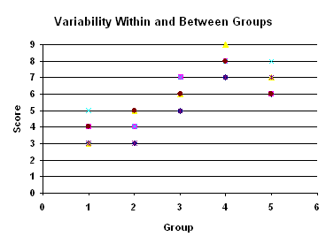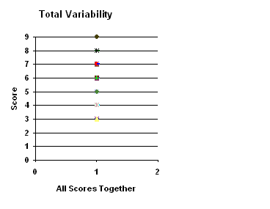
So, ANOVA allows us to take apart this variability (variance) of all the scores and see how much of the variability is from within the groups (within-group variance) and how much is due to the fact that we have different groups with different population means (between-group variance).
Total Variance = Between Group Variance + Within Group Variance
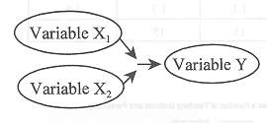

If there is a large amount of the total variance that is due to differences between the groups, then we will conclude that our means for those sample groups came from different populations.
Like for the t-tests where we don't know the population variance we have to estimate it.
The Definitional formula for Estimated Population Variance is:
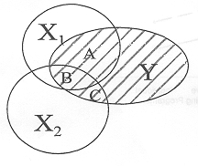
Remember that the numerator of this equation is the sum of each of the deviations from the mean squared. We abbreviate this and call it the Sum of Squares (SS). The definitional formula for variance takes this Sum of Squares and divides it by the number of subjects (less one when we are estimating because we have one less degree of freedom). When we divide a sum by the number of items in that sum we usually call this the mean. Therefore, the definitional formula for variance can also be referred to as the Mean of the Sum of Squares. We abbreviate this and call it the Mean of Squares (MS).
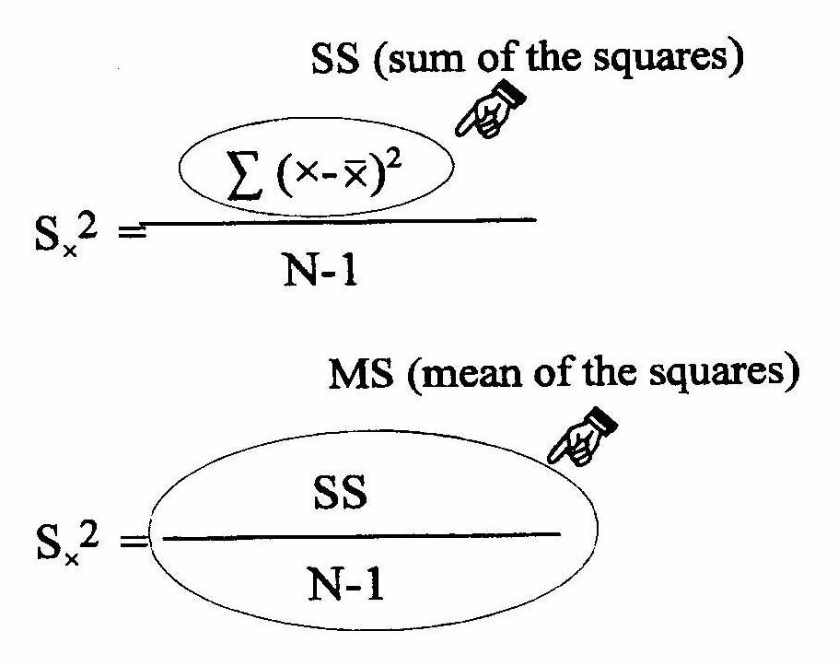

So, estimated population variance is MS = SS/df
Remember that we were going to partition this variance (MS) into two parts; the part due to variance within the groups (MS_{wn}) and the part due to variance between the groups (MS_{bn}).
MS_{wn} is an estimate of the population error (variance that cannot be explained by the independent variable). It is the average variability of the scores in each group around the mean of that group. This is the variability that is due to individual differences, not due to the treatment.
MS_{wn} estimates the population error variance (σ²_{error})
Sample | Estimates | Population
MS_{wn} | ⇒ | σ²_{error}

MS_{bn} is an estimate of both error variance and the treatment variance (effect from the independent variable). It is the average variability of the mean of each group around the grand mean of the entire sample. This is the variability that is due to individual differences and due to the treatment. (σ²_{error} + σ²_{treat})
Sample | Estimates | Population
MS_{bn} | ⇒ | σ²_{error} + σ²_{treat}

The F that we calculate is a ratio of these errors. F = MS_{bn}/ MS_{wn}
Sample | Estimates | Population
F = MS_{bn}  MS_{wn} | ⇒  ⇒ | σ²_{error} + σ²_{treat}  σ²_{error}

If H_{o} is true. Then the treatment has no effect. The variability between groups will be the same as the variability within groups.
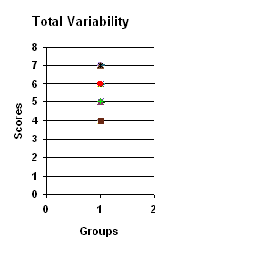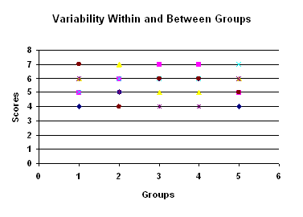
If, like in these graphs, the groups all have means of about 5.5 and the scores vary from 4 to 7, then the total variability (variability due to treatment plus error from individual differences) will be the same as the variability due to error (individual differences). None of the error variability is due to the treatment (σ²_{treat} = 0)
Sample | Estimates | Population
F = MS_{bn}  MS_{wn} | ⇒  ⇒ | σ²_{error} + 0 = 1  σ²_{error .}

If H_{o} is false. Then the treatment has some effect. The variability between groups will greater than the variability within groups.

If, like in these graphs, some of the groups have different means and the scores vary from 3 to 9, then the total variability (variability due to treatment plus error from individual differences) will be greater than the variability due to error (individual differences). Some of the variability is due to the treatment (σ²_{treat} = some amount)
Sample | Estimates | Population
F = MS_{bn}  MS_{wn} | ⇒  ⇒ | σ²_{error} + some amount of σ²_{treat} > 1  σ²_{error .}

When H_{o} is false, H_{a} is true, MS_{bn} is larger than MS_{wn} and F_{obt} is greater than 1.

Calculating F
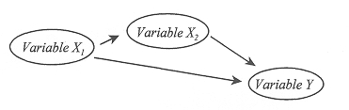
In order to keep all these calculations and results organized, we use the Analysis of Variance Summary Table

Summary Table of One-Way ANOVA
Source | Sum of Squares (SS) | df | Mean Square (MS) | F
Between | SS_{bn} | df_{bn} | MS_{bn} | F_{obt}
Within | SS_{wn} | df_{wn} | MS_{wn}
Total | SS_{tot} | df_{tot}

Conducting the F-Test
F-obtained is tested against the F-critical from the F-table (pages 495-497). There are three things you need to look up the F-Critical.
  - df for within variance (left side column)
  - df for between variance (top row)
  - α
(.05 bold numbers on top, .01 not-bold numbers on the bottom)
F-values are always positive since we are dealing with variance (numbers that have been squared).

Compare your F-obtained to F-critical.
If your F-obtained is bigger than the F-critical then you can reject the null hypothesis and conclude that there is a significant treatment effect.
If your F-obtained is smaller than the F-critical then you fail to reject the null hypothesis.

Report the F-test results
F(df_{bn,} df_{wn}) = ________, p < (or > if smaller than F_{crit}) α.
Graph the results (see example below).

Example 1
Suppose a psychologist examined learning performance under three temperature conditions: (1) 50° , (2) 70° , (3) 90° . The subjects were randomly assigned to one of three treatment groups and learning was measured on a 7 point scale. The data are shown below. What should the psychologist conclude about the effect of temperature on learning? (α = .05)
Group # | Learning (x) | X²
1 | 2 | 4
1 | 2 | 4
1 | 3 | 9
1 | 1 | 1
1 | 2 | 4
2 | 4 | 16
2 | 3 | 9
2 | 6 | 36
2 | 5 | 25
2 | 7 | 49
3 | 1 | 1
3 | 2 | 4
3 | 2 | 4
3 | 3 | 9
3 | 2 | 2
H_{o}:
H_{a}:

ANOVA Summary Table
Source | Sum of Squares (SS) | df | Mean Square (MS) | F
Between | SS_{bn} | df_{bn} | MS_{bn} | F_{obt}
Within | SS_{wn} | df_{wn} | MS_{wn}
Total | SS_{tot} | df_{tot}
F_{crit} ( , ) =
Answer: F( , ) = ________, p .05
Conclusion:
Graph:

Proportion of Variance Accounted For in the Sample (Effect Size)
η² = | SS_{bn}
η² = | SS_{tot}
(η² is called eta squared)
In our example η² =
Estimate of the Proportion of Variance Accounted For in the Population (Effect Size)
ω² = | SS_{bn} - (df_{bn})(MS_{wn})
ω² = | SS_{tot} + MS_{wn}
(ω² is called omega squared)
In our example ω² =

Example 2
A pharmaceutical company has developed a drug that is expected to reduce hunger. To test the drug, 17 rats were randomly assigned to one of three conditions. The first sample received the drug every day, the second was given the drug once a week, and the third sample received no drug at all. The amount of food eaten by each rat over a one month period was measured. Based on the following data can you conclude that the drug effects food intake? (α = .05)
Group # | Food Intake (x) | X²
1 | 2 | 4
1 | 4 | 16
1 | 1 | 1
1 | 1 | 1
1 | 2 | 4
1 | 3 | 9
2 | 4 | 16
2 | 3 | 9
2 | 6 | 36
2 | 10 | 100
2 | 7 | 49
2 | 5 | 25
3 | 11 | 121
3 | 12 | 144
3 | 8 | 64
3 | 5 | 25
3 | 6 | 36
H_{o}:
H_{a}:

ANOVA Summary Table
Source | Sum of Squares (SS) | df | Mean Square (MS) | F
Between | SS_{bn} | df_{bn} | MS_{bn} | F_{obt}
Within | SS_{wn} | df_{wn} | MS_{wn}
Total | SS_{tot} | df_{tot}
F_{crit} ( , ) =
Answer: F( , ) = ________, p .05
Conclusion:
Graph:
Effect size for the sample:
Estimated effect size for the population:

Post-hoc Comparisons
- Fisher's protected t-test (for unequal n's)
Protects the experiment-wise error rate, so that the probability of a type I error for all the comparison's together is <.05.
Notice that the pooled variance is used in the denominator. The t-test procedure is the same as the one's that we have done previously. Always use a two-tailed test.
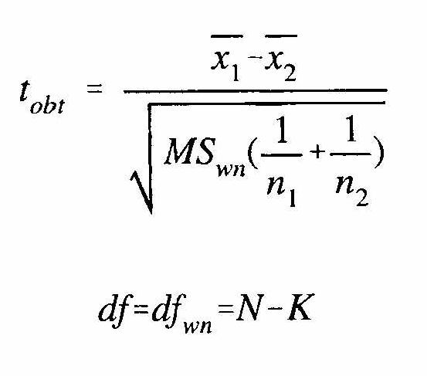
- Tukey's HSD (Honestly Significant Difference)multiple comparisons test: Used only when the n's in all levels of the factor are equal.
Steps:
  - Find q_{k}, using the q-table on pages 498-499. You will need α (.05 bold, .01 not-bold), k (the number of means you are comparing, top row), and df_{wn} (left column).
  - Compute the HSD, (the minimum difference between any two means that is required for them to be considered significantly different).
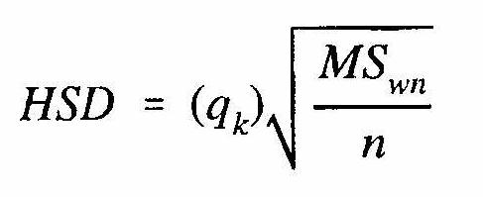
  - Determine which pairs are significantly different (subtract one mean from the other and compare it to HSD, if the difference between your means is bigger than HSD, then the difference is significant.) Use a table to make these comparisons clear (see example below).
Which post-hoc test would you use for example 1?
 |  | ‾x₁ | ‾x₂ | ‾x₃
‾x₁
‾x₂
‾x₃

Which post-hoc test would you use for example 2?
 |  | ‾x₁ | ‾x₂ | ‾x₃
‾x₁
‾x₂
‾x₃

Power
Anything that increases F_{obt} will increase power. That means that having larger differences between the means (MS_{bn} is larger) and decreasing the variability of the scores within conditions (MS_{wn} is smaller) will increase power. Maximizing n in each condition, which increases df_{wn} will also minimize MS_{wn} and increase power.

