Chapter 2 (Sherman Notes) Updated 9/16/15
1. Pitch Static Stability

The most common models for the lift and drag forces on an airfoil are:
$C_{L}=C_{L_{0}}+C_{L_{α}}α$ (1)
$C_{D}=C_{D_{\text{min}}} + {KC}_{L}^{2}$.
The key variable in (1) is the angle of attack, α. Let $x_{\text{cg}}$denote the distance from the wing leading edge to the plane center of gravity (cg), and let $x_{\text{ac}}$denote the distance from the wing leading edge to the plane areodynamic center (ac), Let $h=\frac{x_{\text{cg}}}{\bar{c}}$and $h_{n}=\frac{x_{\text{ac}}}{\bar{c}}$ denote the scaled center of gravity and areodynamic center, respectively, where $\bar{c}$is the airfoil mean chord length. Note that h may be in relation to the airfoil itself, or to the vehicle to which it is attached. In these note, unless otherwise stated, it will denote the distance from the nose of the airplane to the plane’s cg. Then the airfoil moment (scaled by $\text{QS \{}\bar{c}$) is:
$C_{m}=C_{m_{\text{ac}}}+C_{L}(h−h_{n})=C_{m_{\text{ac}}}+ (C_{L_{0}}+C_{L_{α}}α)(h−h_{n})=[C_{m_{\text{ac}}}+ C_{L_{0}}(h−h_{n})]+[C_{L_{α}}(h−h_{n})]α\overset{Δ}{=}C_{m_{0}}+C_{m_{α}}α$. (2)

A key parameter in (2) that controls the longitudinal stability of the plane is the airfoil pitch moment derivative: $C_{m_{α}}=\frac{{\text{dC}}_{m}}{dα}=C_{L_{α}}(h−h_{n})$. It should be noted that, since we require that $C_{L_{α}}>0$, it follows that in order for the wing to be a stabilizing component of the plane (i.e. $C_{m_{α}}<0$. See Example 1 below), it must satisfy $h<h_{n}$. Typically this condition does not hold. In other words, typically the wing is a destabilizing component.

Example 1. Consider three planes have plots of $C_{m}(α)$shown in Figure 1.
Figure 1. Plots of $C_{m}(α)$ for airplanes #1, #2, and #3.

Plane #1 has $C_{m_{α}}>0$, and so a positive perturbation in the pitch angle, α , results in a positive pitching moment, thereby causing α to move further away from equilibrium. Hence, plane #1 is longitudinally unstable. Plane #2 has $C_{m}<0$, and so one might suspect it is longitudinally stable. However, the equilibrium point [i.e. the value of α₀ such that $C_{m}(α_{0})=0$] is negative. This author is not aware of a single plane whose wing is pitched downward. Hence, while, theoretically, plane #2 is longitudinally stable, such a plane probably does not exist. Plane #3 has both $C_{m_{α}}<0$ and $α_{0}>0$. Hence, it is a longitudinally stable real plane. □

Definition 1 For an airplane in a longitudinally balanced (or equilibrium) condition, with corresponding angle of attack, $α_{o}$, (where we will assume only the case $α_{o}≥0$), suppose that the airplane angle of attack is changed to a value $α=α_{o}+Δα$. If the resulting non-zero pitch moment, $C_{m}(α)$acts in a manner to tend to bring the angle of attack back toward$α_{o}$, then the airplane is said to have positive pitch stiffness. If this moment acts in a manner to drive the angle of attack further away from$α_{o}$, then the airplane is said to have negative pitch stiffness. Mathematically, this is equivalent to the condition that the pitch moment derivative satisfy$\frac{∂C_{m}(α)}{∂α}|_{α=α_{0}}<0$. Finally, if $\frac{∂C_{m}(α)}{∂α}|_{α=α_{0}}=0$, then the airplane is said to have zero pitch stiffness (or, the plane is said to have neutral longitudinal stability.)

The two main components of an airplane that contribute to its stability are the wing and the tail. Each
\component has exactly the same lift and moment behavior as that described by (1) and (2), respectively. In the following two sections the details of these expressions will be summarized.

2.1 The Wing (or Wing/Body)
The following equations are for the pitch moment coefficients of the wing.
$C_{L_{w}}=C_{L_{0_{w}}}+ C_{L_{α_{w}}}α$ (3) (2.7)
$C_{m_{w}}=C_{m_{0_{w}}}+C_{m_{α_{w}}}α$ (4) Fig.2.6
where $C_{m_{0_{w}}}=C_{m_{{\text{ac}}_{w}}}+C_{L_{0_{w}}} (h−h_{n_{w}})$ (5) (2.8)
and $C_{m_{α_{w}}}=C_{L_{α_{w}}} (h−h_{n_{w}})$ . (6) (2.9)
The same equations hold for the wing/body; in which case the subscript ‘w’ is replaced by the subscript ‘wb’. In this case, if only the wing(tail)-alone lift derivatives are given, then they must be corrected to account for a finite aspect ratio. This correction is: $C_{L_{α_{\text{wb}}}}=C_{L_{α_{w}}}\left(1+C_{L_{α_{w}}}(π \text{AR})\right)$.

2.2 The Tail
$C_{L_{t}}=C_{L_{α_{t}}}α_{t}=C_{L_{α_{t}}}[α−(i_{w}−i_{t})−ε]$ (7)
where the variables in (7) are defined in Figure 2.7 on p.45 and in Figure 2.9 on p.47.
$C_{m_{t}}=C_{m_{0_{t}}}+C_{m_{α_{t}}}α$ (8)
where $C_{m_{0_{t}}}={ηV}_{H}C_{L_{α_{t}}}[ε_{0}+(i_{w}−i_{t})]$ (9)
and $C_{m_{α_{t}}}=−{ηV}_{H}C_{L_{α_{t}}}\left(1−\frac{dε}{dα}\right)$. (10)
We have: $V_{H}=\frac{l_{t}S_{t}}{\bar{c}S}$, $ε_{0}=\frac{2C_{L_{w}}(α=α_{0})}{π {\text{AR}}_{w}}$, $η=\frac{{{ρV}_{t}^{2}}/2}{{{ρV}_{w}^{2}}/2}=\frac{Q_{t}}{Q_{w}}$ , $\frac{dε}{dα}|_{α_{0}}=\frac{2C_{L_{α_{w}}}}{π {\text{AR}}_{w}}$. (11)
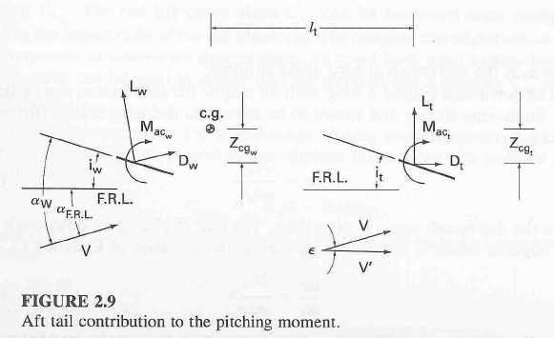
The term $V_{H}$ is called the Horizontal tail Volume ratio. The term $η={Q_{t}}/{Q_{w}}$is called the tail efficiency. Typically, $0\text{.}8<η<1\text{.}2$. The variable $ε$is called the tail downwash angle.
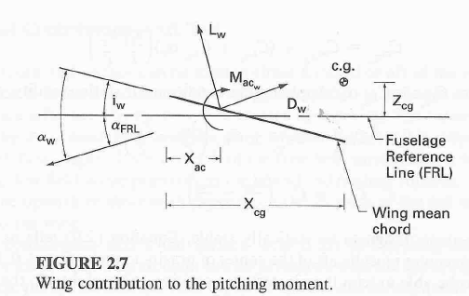

The Entire Plane (i.e. wing/body + tail):
For the airplane lift we have (for $η=1$):

$C_{L}=C_{L_{\text{wb}}}+\left(\frac{S_{t}}{S}\right)C_{L_{t}}=\left[C_{L_{0_{\text{wb}}}}−\left(\frac{S_{t}}{S}\right)C_{L_{α_{t}}}[ε+(i_{w}−i_{t})] \right]+\left[C_{L_{α_{\text{wb}}}}+C_{L_{α_{t}}}\left(\frac{S_{t}}{S}\right)\right] α \overset{Δ}{=} C_{L_{0}}+C_{L_{α}}α$. (12)

For the airplane moment we have:
$C_{m} = (C_{m_{0_{\text{wb}}}}+C_{m_{α_{\text{wb}}}}α)+(C_{m_{0_{t}}}+C_{m_{α_{t}}}α)=\left(C_{m_{0_{\text{wb}}}}+C_{m_{0_{t}}}\right)+\left(C_{m_{α_{\text{wb}}}}+C_{m_{α_{t}}}\right) α \overset{Δ}{=} C_{m_{0}}+C_{m_{α}}α$. (13a)

where, more explicitly:$C_{m_{0}}=C_{m_{0_{\text{wb}}}}+C_{m_{0_{t}}} = C_{m_{{\text{ac}}_{\text{wb}}}}+C_{L_{0_{\text{wb}}}} (h−h_{n_{\text{wb}}})+{ηV}_{H}C_{L_{α_{t}}}[ε_{0}+(i_{w}−i_{t})]$ (13b)
and: $C_{m_{α}} = C_{m_{α_{\text{wb}}}}+C_{m_{α_{t}}}=C_{L_{α_{\text{wb}}}} (h−h_{n_{w}})−{ηV}_{H}C_{L_{α_{t}}}\left(1−\frac{dε}{dα}\right)$. (13c)

[Note: Equations (13) are given in Nelson as equations (2.33-2.35). The latter equations include a fuselage term that is ignored in (13). Those equations also include the subscript ‘w’; whereas in (13) the subscript ‘wb’ is used.]

Example 1 [See Nelson EXAMPLE PROBLEMS 2.1 on p.49 and 2.2 on p.57.]
Given: the wing/body moment equation $C_{m_{\text{wb}}}=−\text{.}\text{05}−\text{.}\text{0035} α$, along with the following wing information:
$S=\text{178} {\text{ft}}^{2} ; b=\text{35}\text{.}9 \text{ft} ; \bar{c}=5\text{ft} ; h_{\text{wb}}={x_{\text{cg}}}/{\bar{c}}=0\text{.}1 ; \text{AR}=7\text{.}3 ;C_{L_{α_{\text{wb}}}}=\text{.}\text{07}\text{rad}\text{/deg} ; C_{L(α=0)}=0\text{.}\text{26} ; i_{w}=2^{o}$. Also, use the following information: $l_{t}=\text{14}\text{.}\text{75}\text{ft} ; {\text{AR}}_{t}=4\text{.}\text{85} ; C_{L_{α_{t}}}=\text{.}\text{073}\text{rad}\text{/deg} ; C_{L(α=0)_{t}}=0\text{.}\text{26} ;η=1\text{.}0$.
Find: the tail $S_{t}$and $i_{t}$ so that the final plane has the moment equation: $C_{m}=\text{.}\text{15}−\text{.}\text{025} α$

Solution:
(i)From (9) and (13b): $C_{m_{0_{t}}}=C_{m_{0}}−C_{m_{0_{\text{wb}}}}=\text{.}\text{15}−(−\text{.}\text{05})=\text{.}\text{20}={ηV}_{H}C_{L_{α_{t}}}[ε_{0}+(i_{w}−i_{t})]=V_{H}(\text{.}\text{073})[ε_{0}+(2^{o}−i_{t})]$ where from (11), $ε_{0}=\frac{2C_{L_{w}}(α=α_{0})}{π {\text{AR}}_{w}}=\frac{2(\text{.}\text{26})}{π(7\text{.}3)}=\text{.}\text{0226}\text{rad}=1\text{.}3^{o}$.
(ii)From (10) and (13c): $C_{m_{α_{t}}}=C_{m_{α}}−C_{m_{α_{\text{wb}}}}=−\text{.}\text{025}−(−\text{.}\text{0035})=−\text{.}\text{0215}=−{ηV}_{H}C_{L_{α_{t}}}\left(1−\frac{dε}{dα}|_{α_{0}}\right)=−(1)V_{H}(\text{.}\text{073})\left(1−\frac{dε}{dα}|_{α_{0}}\right)$ where from (11): $\frac{dε}{dα}|_{α_{0}}=\frac{2C_{L_{α_{w}}}}{π {\text{AR}}_{w}}=\frac{2(\text{.}\text{07})({\text{180}}/π)}{π(7\text{.}3)}=0\text{.}\text{35}$. Hence, we have $\text{.}\text{0215}=(1)V_{H}(\text{.}\text{073})(\text{.}\text{65})$, or $V_{H}=\text{.}\text{453}$. From (11): $S_{t}=\frac{V_{H}\bar{c}S}{l_{t}}=\frac{\text{.}\text{453}(5)(\text{178})}{\text{14}\text{.}\text{75}}=\text{27}\text{.}3{\text{ft}}^{2}$

Returning to (i): $\text{.}\text{20}=\text{.}\text{453}(\text{.}\text{073})[1\text{.}3+(2^{o}−i_{t})]$ gives $i_{t}=−2\text{.}{\text{75}}^{o}$ □

The Stick Fixed Neutral Point- Recall from Definition 1 that the plane will have neutral stability when$\frac{∂C_{m}(α)}{∂α}|_{α=α_{0}}=C_{m_{α}}=0$. In view of (13c), this condition is:$0=C_{L_{α_{\text{wb}}}} (h_{n}−h_{n_{\text{wb}}})−{ηV}_{H}C_{L_{α_{t}}}\left(1−\frac{dε}{dα}\right)$. [Note that here we have defined the neutral point to be $h_{n}\overset{Δ}{=}h$. Nelson denotes this as $h_{\text{NP}}$in
(2.36) on p.56. Note also that for the wing/body alone the neutral point is $h_{n_{\text{wb}}}=h_{\text{ac}}$ In essence, it is how far the cg can be shifted back until the plane becomes neutrally stable.]
Hence, the plane neutral point is: $h_{n}=h_{n_{\text{wb}}}+ \frac{{ηV}_{H}C_{L_{α_{t}}}}{C_{L_{α_{\text{wb}}}}}\left(1−\frac{dε}{dα}\right)=h_{\text{ac}}+ \frac{{ηV}_{H}C_{L_{α_{t}}}}{C_{L_{α_{\text{wb}}}}}\left(1−\frac{dε}{dα}\right)$. (14)
Equation (14) is equation (2.36) on p.56 of Nelson.

Definition: The stick-fixed neutral point of a plane is defined as (14).

Notice that for the wing/body, $h_{n}=h_{n_{\text{wb}}}=h_{\text{ac}}$. Whereas, for the entire plane it is greater by the amount given by the additional term in (14). From (11), we have $\frac{dε}{dα}|_{α_{0}}=\frac{2C_{L_{α_{w}}}}{π {\text{AR}}_{w}}$. If this term is close to one, then the neutral point will be close to that of the wing/body. In other words, the tail contributes a ‘factor of safety’ in relation to how far aft the cg can move. [Note: Equation (14) ignores the body contribution included in Nelson (2.36).]

Example 1 (continued). How much of a ‘cushion’ does the tail contribute to $h_{n}$ ?
Answer: $\frac{{ηV}_{H}C_{L_{α_{t}}}}{C_{L_{α_{\text{wb}}}}}\left(1−\frac{dε}{dα}\right)=\frac{\text{.}\text{0215}}{\text{.}\text{07}}=0\text{.}\text{307}$ and $h={x_{\text{cg}}}/{\bar{c}}=0\text{.}1$. Hence, it contributes quite a bit! □

Clearly, the difference $h−h_{n}$plays a major role in relation to longitudinal stability. For $h<h_{n}$, we have $C_{m_{α}}<0$, hence positive stiffness. This can always be achieved if the airplane CG is positioned sufficiently toward the front of the airplane. The difference $h−h_{n}$is of such importance, that the negative of it is defined as the static margin: $h_{n}−h\overset{Δ}{=}K_{n}$.
From (14), we have: $h_{n_{\text{wb}}}=h_{n}− \frac{{ηV}_{H}C_{L_{α_{t}}}}{C_{L_{α_{\text{wb}}}}}\left(1−\frac{dε}{dα}\right)$. (15)

While (14) is convenient for some purposes, it is not convenient for clearly understanding how a change in the plane scaled cg, h, influences its neutral point, $h_{n}$. This is because the quantity $V_{H}=\frac{l_{t}S_{t}}{\bar{c}S}$includes the term ${l_{t}}/{\bar{c}}=h_{n_{t}}−h$ Following Etkin, define ${{\bar{l}}_{t}}/{\bar{c}}=h_{n_{t}}−h_{n_{\text{wb}}}$. Then ${l_{t}}/{\bar{c}}=({{\bar{l}}_{t}}/{\bar{c}})−(h−h_{n_{\text{wb}}})$. Hence,
$V_{H}=\frac{l_{t}S_{t}}{\bar{c}S}=\left[\frac{{\bar{l}}_{t}}{\bar{c}}−(h−h_{n_{\text{wb}}})\right]\left(\frac{S_{t}}{S}\right)=\frac{{\bar{l}}_{t}S_{t}}{\bar{c}S}−\left(\frac{S_{t}}{S}\right)(h−h_{n_{\text{wb}}}) \overset{Δ}{=}{\bar{}V}_{H}−\left(\frac{S_{t}}{S}\right)(h−h_{n_{\text{wb}}})$. (16)

At this point, rather than using the above final equations, it is more expedient to recall the following:

$M_{t}=−L_{t}l_{t}=−\left[C_{L_{t}}\left(\frac{1}{2}{ρV}_{t}^{2}S_{t}\right)\right]l_{t} ⇒ C_{m_{t}}=\frac{M_{t}}{\frac{1}{2}{ρV}^{2}S\bar{c}}=−{ηV}_{H}C_{L_{t}}$. (17)
Using (16), this becomes: $C_{m_{t}}=−η\left[{\bar{V}}_{H}−\left(\frac{S_{t}}{S}\right)(h−h_{n_{\text{wb}}})\right]C_{L_{t}}$. (18)
It follows that $C_{m}=C_{m_{\text{wb}}}+C_{m_{t}}=\left[C_{m_{{\text{ac}}_{\text{wb}}}}+C_{L_{\text{wb}}}(h−h_{n_{\text{wb}}})\right]−η\left[{\bar{V}}_{H}−\left(\frac{S_{t}}{S}\right)(h−h_{n_{\text{wb}}})\right]C_{L_{t}}$.
Gathering terms: $C_{m}=C_{m_{{\text{ac}}_{\text{wb}}}}+\left[C_{L_{\text{wb}}}+η\left(\frac{S_{t}}{S}\right)C_{L_{t}}\right](h−h_{n_{\text{wb}}})−η{\bar{V}}_{H}C_{L_{t}}$. (19)
At this point we will make the following: Assumption: $η\overset{Δ}{=}({V_{t}}/V)^{2}≃1$. Then in view of the leftmost equality in (12), (19) becomes: $C_{m}=C_{m_{{\text{ac}}_{\text{wb}}}}+C_{L}(h−h_{n_{\text{wb}}})−{\bar{V}}_{H}C_{L_{t}}$. (20)
From (20) we have: $C_{m_{α}}=C_{L_{{}_{α}}}(h−h_{n_{\text{wb}}})−{\bar{V}}_{H}\frac{∂C_{L_{t}}}{∂α}$. (21)
From (21) for the case of neutral pitch stability ($C_{m_{α}}=0$)we have:$0=C_{L_{{}_{α}}}(h_{n}−h_{n_{\text{wb}}})−{\bar{V}}_{H}\frac{∂C_{L_{t}}}{∂α}$ (22)
From (22) we have: $h_{n}=h_{n_{\text{wb}}}+\left(\frac{{\bar{V}}_{H}}{C_{L_{{}_{α}}}}\right)\frac{∂C_{L_{t}}}{∂α}$ (23)
From (22) we also have: $h_{n_{\text{wb}}}=h_{n}−\left(\frac{{\bar{V}}_{H}}{C_{L_{{}_{α}}}}\right)\frac{∂C_{L_{t}}}{∂α}$. (24)

Substituting (24) into (21): $C_{m_{α}}=C_{L_{{}_{α}}}(h−h_{n})$. (25)

Equation (25) is exactly what one might expect, assuming that the neutral point is, indeed, the plane aerodynamic center.

For a given airplane configuration, suppose h is known. Solving (25) for $h_{n}$gives:
$h_{n}=h−({C_{m_{α}}}/{C_{L_{{}_{α}}}})$. (26)
Now note that ${C_{m_{α}}}/{C_{L_{{}_{α}}}}\overset{Δ}{=}\frac{∂C_{m}∂α}{∂C_{L}∂α}=\frac{{\text{dC}}_{m}}{{\text{dC}}_{L}}$ (27)
equation (26) becomes: $h_{n}≃h−({{\text{dC}}_{m}}/{{\text{dC}}_{L}})$. (28)
Equation (28) provides an alternative to the use of pitch derivatives in experimentally estimating $h_{n}$. Notice that it holds for any angle of attack, α. Experimental measurement of the amount of change in the pitch moment coefficient that results from a small change in the lift moment coefficient (generated by, for example, a small change in α) will yield an estimate of $h_{n}$. The accuracy of such an estimate can be improved by repeating the test at a variety of specified values for α, and using the average.
Example 2. An aircraft is to be operated with its most rearward CG position limited to 25 ft. aft of the apex of the wing. The distance between the wing and tail mean aerodynamic centers is ${\bar{l}}_{t}=\text{55}$ft., the distance to the wing/body aerodynamic center is $x_{{\text{ac}}_{\text{wb}}}=\text{21}$ ft., and the wing mean chord length is $\bar{c}=\text{19}\text{.}\text{26}$ft. Estimate the area ratio ${S_{t}}/S$, required to provide a control-fixed static margin, $h_{n}−h=K_{n}$, of at least 0.05 at all times. Make the following assumptions:(A1) $a_{t}=a_{\text{wb}}$;(A2) $h_{n_{w}}=h_{n_{\text{wb}}}$;(A3) no power plant effects ;(A4) $∂ε/∂α=0\text{.}\text{25}$.
Solution: We are given:$h\bar{c}=\text{25} \text{ft}$, or . We are also given $h_{n_{\text{wb}}}\bar{c}=\text{21} \text{ft}$, or$h_{n_{\text{wb}}}={\text{21}}/{\text{19}}\text{.}\text{26} =1\text{.}\text{09}$.
From (16): $V_{H}=\left(\frac{S_{t}}{S}\right)\left[\frac{{\bar{l}}_{t}}{\bar{c}}−(h−h_{n_{\text{wb}}})\right] =\left(\frac{S_{t}}{S}\right)\left[\frac{\text{55}}{\text{19}\text{.}\text{26}}−(1\text{.}\text{30}−1\text{.}\text{09})\right] =\left(\frac{S_{t}}{S}\right)(2\text{.}\text{646})$
From (14):
Hence, $h_{n}=K_{n}+h =\text{.}\text{05}+1\text{.}\text{30}=1\text{.}\text{35}=1\text{.}\text{09}+1\text{.}\text{985} \left(\frac{S_{t}}{S}\right)$. Hence, $\frac{S_{t}}{S}=0\text{.}\text{131}$ □

2.3 Longitudinal Control
Deflection of the elevator through an angle $δ_{e}$will result in a change in both the lift and pitching moment of the aircraft. A downward elevator motion is taken to be positive. It will produce positive lift and negative pitching moment. If we assume these quantities are linear in $δ_{e}$, then we obtain:
$C_{L}=C_{L_{α}}α+C_{L_{δ_{e}}}δ_{e}$ (29)

$C_{m}=C_{m_{0}}+C_{m_{α}}α+C_{m_{δ_{e}}}δ_{e}$ (30)

Example 3. Consider the NAVION airplane described in Table B.1 on p.400 of Nelson.

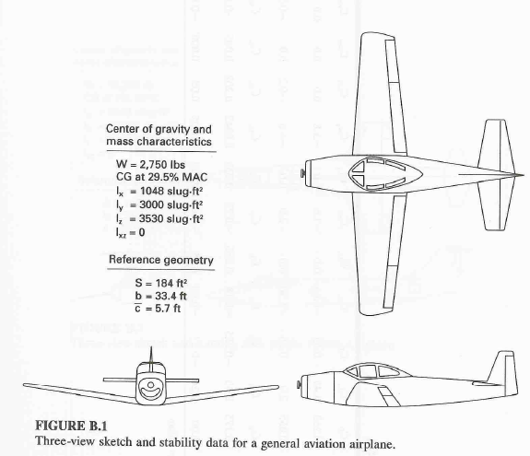
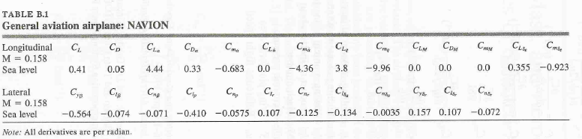

(a)When flying in the equilibrium condition with $δ_{e}=0$, find the angle of attack, $α_{o}$.
Solution: $C_{L}(α,0)=\frac{W}{0\text{.}5{ρV}^{2}S}=\frac{\text{2750}}{0\text{.}5(\text{.}\text{002377})(\text{.}\text{158}×\text{1116}\text{.}4)^{2}(\text{184})}=\text{.}\text{40417}$. Also, $C_{L_{α}}=4\text{.}{\text{44}}/{\text{rad}}$.
Hence, $α_{o}=\frac{\text{.}\text{40417}}{4\text{.}\text{44}}=\text{.}\text{091}\text{rad}=5\text{.}{\text{214}}^{o}$

(b) Notice that $C_{m_{0}}$is not given in Table B.1. Use your result in (a) to find it.
Solution: $0=C_{m_{0}}+C_{m_{α}}α_{o} ⇒ C_{m_{0}}=−C_{m_{α}}α_{o}=−(−\text{.}\text{683})(\text{.}\text{091})=\text{.}{\text{062}}/{\text{rad}}$.

(c) Find the values of $α$ and $δ_{e}$needed for a vertical acceleration of 0.1g’s.
Solution: Now the Lift is $L=1\text{.}1 W=\text{3025}$, and so $C_{L}(α,0)=\text{.}\text{4041}(1\text{.}1)=\text{.}\text{4445}$. Hence, from (30):
$0=C_{m_{0}}+C_{m_{α}}α+C_{m_{δ_{e}}}δ_{e}$ or $−C_{m_{0}}=C_{m_{α}}α+C_{m_{δ_{e}}}δ_{e}$. This, along with (29) give the matrix equation:
$\left[\begin{matrix}\text{.}\text{4445} \\ −\text{.}\text{062}\end{matrix}\right]=\left[\begin{matrix}C_{L_{α}} & C_{L_{δ_{e}}} \\ C_{m_{α}} & C_{m_{δ_{e}}}\end{matrix}\right] \left[\begin{matrix}α \\ δ_{e}\end{matrix}\right]=\left[\begin{matrix}4\text{.}\text{44} & \text{.}\text{355} \\ −\text{.}\text{683} & −\text{.}\text{923}\end{matrix}\right] \left[\begin{matrix}α \\ δ_{e}\end{matrix}\right]$. Hence, $\left[\begin{matrix}α \\ δ_{e}\end{matrix}\right]=\left[\begin{matrix}\text{.}\text{1007}\text{rad} \\ \text{.}\text{0073}\text{rad}\end{matrix}\right]=\left[\begin{matrix}5\text{.}{\text{77}}^{o} \\ −\text{.}{\text{42}}^{o}\end{matrix}\right]$.

(d) Is your answer your answer in (c) consistent with Figure 2.20 on p.63 of Nelson?
Answer: Yes. The trim angle of attack moved to the right when the elevator angle became negative. Specifically, for this elevator setting we now have
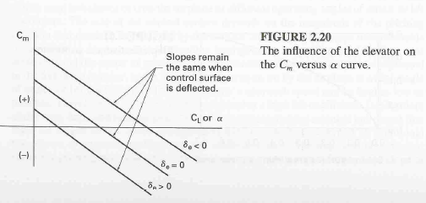
$$\begin{aligned}C_{m}(α,δ_{e}=−\text{.}{\text{42}}^{o})=C_{m_{0}}+C_{m_{α}}α+C_{m_{δ_{e}}}(−\text{.}{\text{42}×π}/{{\text{180}}^{o}})=C_{m_{0}}+C_{m_{α}}α+(−\text{.}\text{923})(−\text{.}{\text{42}×π}/{{\text{180}}^{o}}) \\ =(\text{.}\text{0068}+C_{m_{0}})+C_{m_{α}}α=C(δ_{e})+C_{m_{α}}α\end{aligned}$$

Notice that the $C_{m} \text{vs}\text{.} α$ line has a smaller
intercept but has the same slope.

Q: What about the $C_{L} \text{vs}\text{.} α$line?

The Derivatives $C_{L_{δ_{e}}}$and $C_{m_{δ_{e}}}$(The following corresponds to the development in Nelson.)

The Lift Derivative $C_{L_{δ_{e}}}$: A deflection, ${Δδ}_{e}$, of the elevator will produce a lift force, ${ΔL}_{t}=ΔL$, at the tail of the plane, and hence a change in the corresponding lift coefficient:

${ΔC}_{L}=\frac{ΔL}{0\text{.}5{ρV}^{2}S}\left(\frac{0\text{.}5{ρV}_{t}^{2}S_{t}}{0\text{.}5{ρV}_{t}^{2}S_{t}}\right)={\left(\frac{V_{t}}{V}\right)}^{2}\left(\frac{S_{t}}{S}\right){ΔC}_{L_{t}}=η\left(\frac{S_{t}}{S}\right){ΔC}_{L_{t}}$

Write ${ΔC}_{L_{t}}≃\frac{{\text{dC}}_{L_{t}}}{{dδ}_{e}} {Δδ}_{e}=\frac{{\text{dC}}_{L_{t}}}{{dα}_{t}} \frac{{dα}_{t}}{{dδ}_{e}} {Δδ}_{e} = C_{L_{α_{t}}}τ {Δδ}_{e}$ where we have defined the parameter $τ={{dα}_{t}}/{{dδ}_{e}}$. We then have: ${ΔC}_{L}=η\left(\frac{S_{t}}{S}\right)C_{L_{α_{t}}}τ {Δδ}_{e}$, or $\frac{{ΔC}_{L}}{{Δδ}_{e}}=η\left(\frac{S_{t}}{S}\right)C_{L_{α_{t}}}τ$.
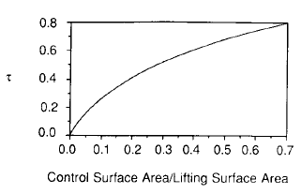
Hence: $C_{L_{δ_{e}}}=\left[η τ\left(\frac{S_{t}}{S}\right)\right]C_{L_{α_{t}}}$. (31)

The parameter $τ={{dα}_{t}}/{{dδ}_{e}}$is shown as a function of ${S_{e}}/{S_{t}}$
in Figure 2.21 on p.64 of Nelson.
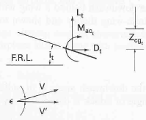

Figure 2.21 on p.64 of Nelson

From Figure 2.9 of Nelson, the black line is the tail chord line for $δ_{e}=0$. The blue line is the tail chord line for a positive elevator angle (red).

Q: What about the $C_{L} \text{vs}\text{.} α$line?
A: From (29): $C_{L}(α,δ_{e})=C_{L_{α}}α+C_{L_{δ_{e}}}δ_{e}=C_{L_{α}}α+C_{L_{0}}(δ_{e})$. In words, for a given $δ_{e}$, the lift line intercept is changed. The slope remains the same. This is shown
in the figure at the right.

The Moment Derivative $C_{m_{δ_{e}}}$: The change in the plane pitching moment is described by:

Note that:${ΔC}_{m}=−{ηV}_{H}{ΔC}_{L_{t}}=−{ηV}_{H}\left(C_{L_{α_{t}}}τ {Δδ}_{e}\right)$, or $\frac{{ΔC}_{m}}{{Δδ}_{e}}=−{ηV}_{H}C_{L_{α_{t}}}τ$.

Hence: $C_{m_{δ_{e}}}=−\left(η {τV}_{H}\right)C_{L_{α_{t}}}$. (32)

The quantity in (32) is called the elevator control power. Using (16), we can also express (32) as:

$C_{m_{δ_{e}}}=−η\left[{\bar{V}}_{H}−\left(\frac{S_{t}}{S}\right)(h−h_{n_{\text{wb}}})\right]C_{L_{α_{t}}}τ$. (33)
Notice that (33) shows how the elevator moment derivative, $C_{m_{δ_{e}}}$, changes, as a function of the plane scaled cg location, h.

Example 4. Consider again the NAVION plane addressed in Example 3. Find the elevator area, $S_{e}$.
Solution: While not given in Figure B.1 on p.401 of Nelson, in EXAMPLE PROBLEM 2.2 on p.57, we are given that $S_{t}=\text{43}{\text{ft}}^{2}$. Hence, (see p.58), we have $V_{H}=0\text{.}\text{66}$. Assume that $η=1$. From the top of p.58, we also have . Then from (32) and Table B.1 we have $τ=\frac{−C_{m_{δ_{e}}}}{{ηV}_{H}C_{L_{α_{t}}}}=\frac{−(−\text{.}\text{923})}{\text{.}\text{66}(3\text{.}\text{91})}=0\text{.}\text{358}$. For this value, our estimate of ${S_{e}}/{S_{t}}$from Figure 2.21 on p.64 of Nelson is: ${S_{e}}/{S_{t}}≃0\text{.}\text{17}$. Hence, the elevator area is $S_{e}≃0\text{.}\text{17}S_{t}=\text{.}\text{17}(\text{43})=7\text{.}\text{31}{\text{ft}}^{2}$.

Expressions for $α_{\text{trim}}$and $δ_{e_{\text{trim}}}$- In the case of a trimmed condition, where $C_{m}\overset{Δ}{=}C_{m}(α,δ_{e})=0$, equations (29) and (30) yield:

$α_{\text{trim}}=(C_{m_{δ_{e}}}C_{L_{\text{trim}}}+C_{L_{δ_{e}}}C_{m_{0}})\text{/det}$ (34a)
and $δ_{e_{\text{trim}}}=−(C_{m_{α}}C_{L_{\text{trim}}}+C_{L_{α}}C_{m_{0}})\text{/det}$ (34b)
where $\text{det}=C_{L_{α}}C_{m_{δ_{e}}}−C_{L_{δ_{e}}}C_{m_{α}}$. (34c)

SEE IF YOU CAN DERIVE (34) from (28) & (29).

NOTE: The three variables in (34) include $C_{L_{\text{trim}}}$, $α_{\text{trim}}$, and $δ_{e_{\text{trim}}}$. Specifying any one will determine the other two. For example, a specified value for $C_{L_{\text{trim}}}$will determine both $α_{\text{trim}}$ and $δ_{e_{\text{trim}}}$.

Solving (34a) for $C_{L_{\text{trim}}}$gives:
$C_{L_{\text{trim}}}=C_{L_{α}}\left[1−\left(\frac{C_{L_{δ_{e}}}}{C_{L_{α}}}\right) \left(\frac{C_{m_{α}}}{C_{m_{δ_{e}}}}\right)\right] α_{\text{trim}} − C_{L_{δ_{e}}}\left(\frac{C_{m_{0}}}{C_{m_{δ_{e}}}}\right)$. (35)

Equation (35) is called the trimmed lift curve. There are a number of points to note in relation to this curve:
Point 1: The trimmed lift is a linear function of the trimmed angle of attack.

Point 2: The rate change in the trimmed lift is smaller for $δ_{e}=0$ [i.e. the basic condition shown in Figure 2.17 on p.37 of Etkin] than it is for $δ_{e}=δ_{e_{\text{trim}}}>0$. Specifically, it is smaller by a fractional amount
$0≤\left(\frac{C_{L_{δ_{e}}}}{C_{L_{α}}}\right) \left(\frac{C_{m_{α}}}{C_{m_{δ_{e}}}}\right) <1$.
Note that since both $C_{m_{δ_{e}}}$and $C_{m_{α}}$are negative, this quantity is positive. (See Remark 1 on p.21 of these notes.)

Point 3: The zero-trimmed-lift angle of attack is no longer zero, but rather, is positive. Specifically, it is
$α_{\text{trim}}= −C_{L_{δ_{e}}}\left(\frac{C_{m_{0}}}{|C_{m_{δ_{e}}}|}\right)\left[1−\left(\frac{C_{L_{δ_{e}}}}{C_{L_{α}}}\right) \left(\frac{C_{m_{α}}}{C_{m_{δ_{e}}}}\right)\right] ; \text{for} C_{L_{\text{trim}}}=0$
Point 4: The lift at $α_{\text{trim}}=0$is positive. Specifically:
$C_{L_{\text{trim}}}( α_{\text{trim}}=0)= C_{L_{δ_{e}}}\left(\frac{C_{m_{0}}}{|C_{m_{δ_{e}}}|}\right)$.
These points are illustrated in Figure 2:

Figure 2. Plots of aircraft $α$(re: zero-lift) versus lift coefficient, $C_{L}$for basic and trimmed conditions.
Example 5. [Nelson. 2.4 on p.86] The $C_{m}$versus $α$curves for various values of $δ_{e}$are shown below. We also have: (i) $C_{L}=\text{.}\text{03}+\text{.}\text{08} α (\text{deg}\text{.})$, and (ii) $−{\text{15}}^{o}≤δ_{e}≤{\text{15}}^{o}$.
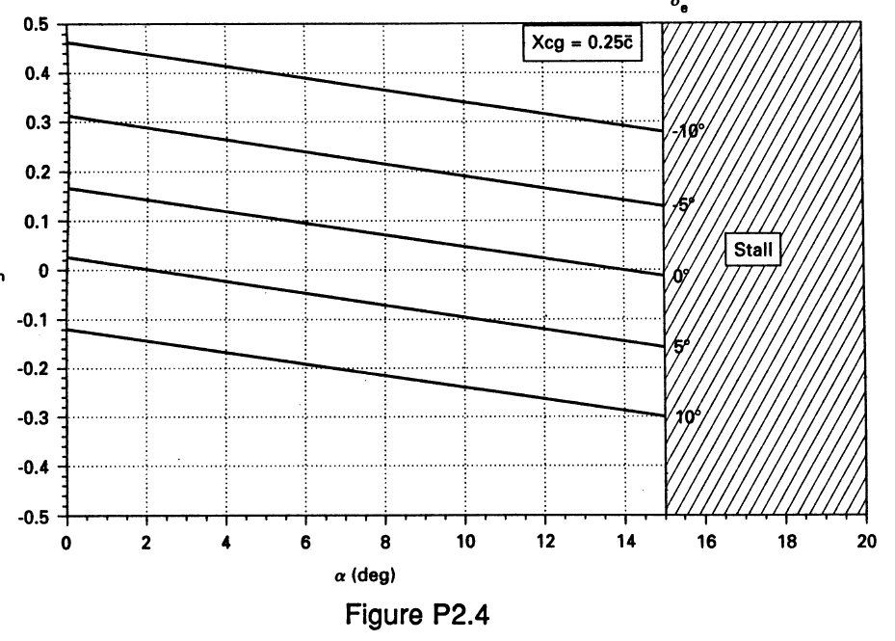
(a)Estimate the fixed stick neutral point.
Solution: From (26), we have $h_{n}=h−({C_{m_{α}}}/{C_{L_{{}_{α}}}})$. From the above figure, $C_{m_{α}}=\frac{{\text{dC}}_{m}}{dα}\frac{−\text{.}3−(−\text{.}\text{12})}{\text{15}}=−\text{.}\text{012}\text{/deg}$. From (i) we have $C_{L_{α}}=\text{.}\text{08}\text{/deg}$. From the upper right corner of the figure, we have $h=\text{.}\text{25}$. Hence,
$h_{n}=\text{.}\text{25}−(−\text{.}{\text{012}}/{\text{.}}\text{08})=\text{.}4$.
(b)Estimate the control power, $C_{m_{δ_{e}}}$. Solution: $C_{m_{δ_{e}}}=\frac{{\text{dC}}_{m}}{{dδ}_{e}}\frac{−\text{.}\text{12}−\text{.}\text{02}}{\text{10}−5}=−\text{.}\text{028}\text{/deg}$
(c)Find the forward cg limit.
Solution:
- Clearly, the largest value of h is the neutral point, $h_{\text{NP}}=h_{n}$. A larger value will result in a plane that is statically unstable. The smallest value of h is not related to stability, but rather to the ability to trim the plane at large values of $C_{L}$(e.g. when landing the plane). From the figure, we have:
$C_{L_{\text{max}}}=\text{.}\text{03}+\text{.}\text{08} ({\text{15}}^{o})=1\text{.}\text{23}$.
- As the cg is moved forward, the $C_{m}$versus $α$curves in the figure will become steeper. In other words, the magnitude of$C_{m_{α}}$will increase. This must be countered by an increase in the elevator moment. If we assume that $C_{m_{δ_{e}}}$is not significantly influenced by the movement of the cg, then the maximum positive elevator moment is:
$C_{m_{\text{max}}}\overset{Δ}{=}C_{m_{δ_{e}}}δ_{e_{\text{max}}}\text{==}−\text{.}\text{028} (−\text{15})=0\text{.}\text{42}$.
- From (30) at the trim condition, we have: $C_{m_{\text{trim}}}=0=C_{m_{0}}+C_{m_{α}}α_{\text{max}}+C_{m_{δ_{e}}}δ_{e_{\text{max}}}$, or
$C_{m_{α}}=−(C_{m_{0}}+C_{m_{δ_{e}}}δ_{e_{\text{max}}})/{α_{\text{max}}}$.
From the figure ($δ_{e}=0^{o}$line in RED), $m_{0}≃0\text{.}\text{17}$. Hence, $C_{m_{α}}=−(\text{.}\text{17}+\text{.}\text{42})/{\text{15}} = −\text{.}\text{039}$.

- Again, from (26) we have: $h=h_{n}+({C_{m_{α}}}/{C_{L_{{}_{α}}}})=0\text{.}4+(−\text{.}{\text{039}}/{\text{.}}\text{08})=−\text{.}\text{087}$. In words, the forward cg limit is slightly ahead of the front of $\bar{c}$. □

Example 6. [Nelson Problem 2.10 on p.90] The airplane in Example 5 has the following hinge moment characteristics:
$C_{L_{α_{w}}}=\text{.}\text{09}/^{o} ; C_{L_{α_{t}}}=\text{.}\text{08}/^{o} ; C_{h_{α}}=−\text{.}\text{003}/^{o} ; C_{h_{0}}=0 ; C_{h_{δ}}=−\text{.}\text{005}/^{o} ; C_{h_{0}}=0 ; S_{e}S_{t}=\text{.}\text{35} ; V_{H}=\text{.}4 ; {dε}/{dα}=\text{.}4$.
Find the stick free neutral point.
Solution: From (2.64) on p.70: $h_{n}^{'}=h_{n}−(1−f)V_{H}η\frac{C_{L_{α_{t}}}}{C_{L_{α_{w}}}}\left(1−{dε}/{dα}\right)$ where $f=1−\frac{C_{L_{δ_{e}}}}{C_{h_{δ_{e}}}}\frac{C_{h_{α_{t}}}}{C_{L_{α_{t}}}}$. The only quantity not given is $C_{L_{δ_{e}}}$. From (31), we have $C_{L_{δ_{e}}}=\left[η τ\left(\frac{S_{t}}{S}\right)\right]C_{L_{α_{t}}}$. The only quantity in this expression not given is $τ$; which can be estimated from Nelson FIGURE 2.21 on p.64 as: $τ≃\text{.}\text{55}$. We then obtain $C_{L_{δ_{e}}}=\text{.}\text{0154}/^{o}$, and then $f=\text{.}\text{88}$. From Example 5 we found $h_{n}=\text{.}4$. Finally, $h_{n}^{'}=\text{.}4−\text{.}\text{0256}=\text{.}\text{3744}$. Notice that this stick free neutral point lies ahead of the stick fixed neutral point. □

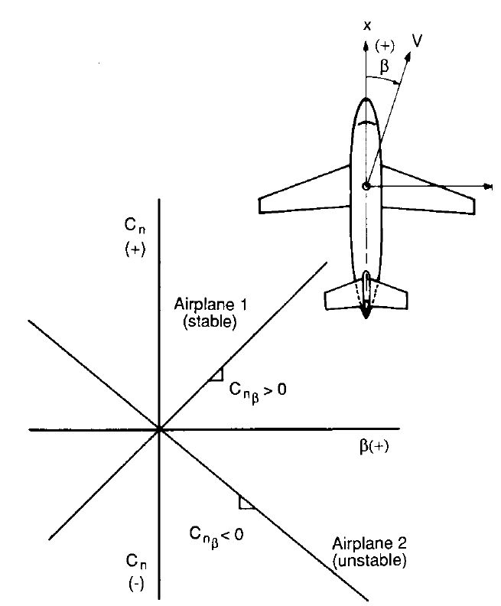
2. Yaw (Directional) Static Stability [Nelson p.73]

The yaw angle, $β$, is defined to be positive if the
plane is yawing left, as shown in Figure 2.28 of Nelson.
Recall that clockwise moments are defined to be positive
moments. Hence, for the situation shown in this figure,
a positive tail rudder moment is needed to eliminate
the yaw. The graph in this figure reflects this fact, in
relation to the yaw moment derivative, $C_{n_{β}}$.

Definition 2.2.1 An airplane posseses directional,
or weathercock stability if $C_{n_{β}}>0$.
The yaw moment has two contributions: one associated
with the wing/fuselage, and the other associated with the
rudder.
Figure 2.28 on p.73 of Nelson. Static directional stability.

The wing/fuselage contribution-
Repeating (2.73) on p.74 of Nelson here: $C_{n_{β_{\text{wb}}}}=−k_{n}k_{\text{Rl}}\frac{S_{\text{fs}}l_{f}}{Sb} (\text{/deg})$. (36)
The quantities S and b are the wing area and length, respectively. The new quantities introduced in (36)
include:
$k_{n}$= an empirical wing/body interference factor that is a function of the fuselage geometry.
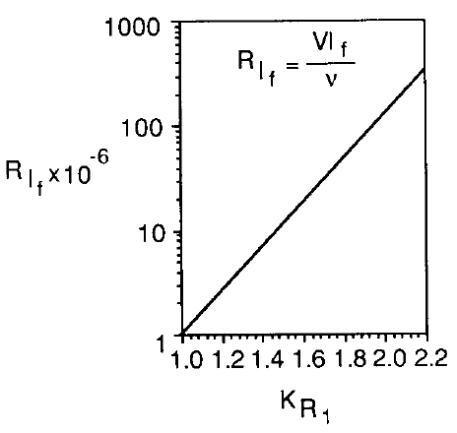
$k_{\text{Rl}}$= an empirical correction factor that is a function of the fuselage Reynolds number.
$S_{\text{fs}}$= the projected side area of the fuselage.
$l_{f}$= the total length of the fuselage (from nose tip to back of tail).

The parameter $k_{\text{Rl}}$is related to the body Reynolds number
$R_{l_{f}}={Vl}_{f}ν$ as shown in Nelson Figure 2.30 at the right.
[Note: $ν$is the kinematic viscosity of the air.]

Figure 2.30 (p.75) Reynold number correction.

While $k_{\text{Rl}}$is straightforward to obtain. The interference factor $k_{n}$is not. For this reason, I have chosen to include Figure 2.29 (p.75), along with enhancements, on the following page of these notes.

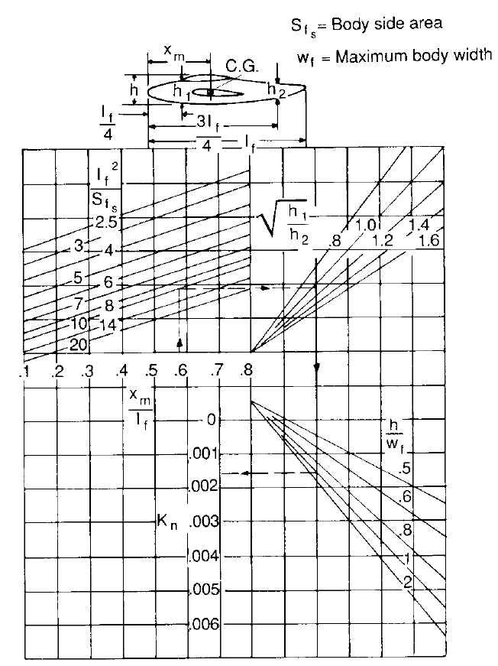

Figure 2.29 on p.75 of Nelson. Wing/body interference factor $k_{n}$

The path in red illustrates how $k_{n}$ is arrived at. One begins with knowledge of ${x_{m}}/{l_{f}}$, where $x_{m}$is the distance from the tip of the nose to the plane cg. Knowledge of $({l_{f}}/{S_{\text{fs}}})^{2}$gives the first leg of the path. Knowledge of the shown fuselage height ratio ${h_{1}}/{h_{2}}$gives the second leg. Knowledge of the ratio $h/{w_{f}}$
completes the third leg, allowing one to then estimate $k_{n}$in the fourth and final leg.
The vertical tail contribution-
The magnitude of the side force acting on the vertical tail can be expressed as:

$Y_{v}=\left(−C_{L_{α_{v}}}\right) α_{v}(Q_{v}S_{v})$ where we have assumed $C_{L_{α_{v}}}>0$. (2.75) (37)
The vertical angle of attack, $α_{v}$ is : $α_{v}=β+σ$ (38)
where $σ$is the sidewash angle [See Figure 2.31 on p.76 of Nelson]. From (37) and (38) we have:

$C_{L_{v}}=−C_{L_{α_{v}}}α_{v}=−C_{L_{α_{v}}}(β+σ)$ . (39)

From (39): $\frac{{\text{dC}}_{L_{v}}}{dβ} = −C_{L_{α_{v}}}\left(1+\frac{∂σ}{∂β}\right) \overset{Δ}{=} C_{L_{β}}$. (40)

It is important to note that $C_{L_{β}}<0$ is necessary for yaw stability. It is also important to have the explicit definition (40) of $C_{L_{β}}$. No such definition is given in the development on pp.74-77 of Nelson; even though this parameter is one of the many included, for example, in the NAVION Table B.1 on p.400.

It follows that the restoring moment produced by the vertical tail is:

$N_{v}=−Y_{v}l_{v}=l_{v}C_{L_{α_{v}}}(β+σ)(Q_{v}S_{v})=−l_{v}\left(\frac{C_{L_{β}}}{1+∂σ/∂β}\right)(β+σ)(Q_{v}S_{v})$. (41)

This moment is positive due to the fact that the force (37) is in the negative y direction, and it is applied at the negative x location $l_{v}$.

Note: Equation (37) is consistent with (2.74) on p.74 of Nelson. However, the middle equality in (39) is not consistent with the middle equality in (2.76). This differs from (39) by a minus sign. The rightmost equalities of (39) and (2.76) are the same. Hence, it would appear that a minus sign is missing from the middle equality of (2.76). While this point may seem minor, it can cause confusion as to the sign convention concerning the yaw angle, $β$, and the sidewash angle, $σ$. Specifically, (38) suggests that $σ$increases the rudder angle of attack, $α_{v}$. Now, consider the figure below.

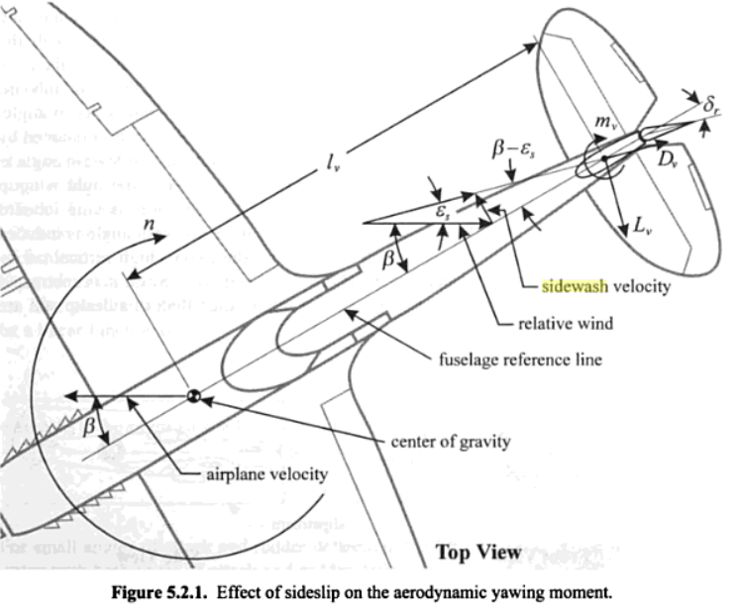
[From Mechanics of Flight by W. Phillips]

This figure illustrates that the sidewash actually decreases the rudder angle of attack. In other words, (38) should be $α_{v}=β−σ$. In Etkin we find $α_{v}=−β+σ$; but only because of his sign convention for $α_{v}$. In fact, as noted by Phillips, there is no accepted convention for either the yaw or the sidewash angle. The only way that Nelson’s expression (38) is consistent with sidewash reducing the rudder angle of attack is if $σ$is assumed to be negative. If we make this assumption, then the yaw moment derivative given in (43) below is actually reduced as a result of the sidewash gradient.

From (41) we have:
$C_{n_{v}}=−V_{v}η_{v}\left(\frac{C_{L_{β}}}{1+∂σ/∂β}\right)(β+σ)$ (42)

The vertical tail stability derivative is, therefore:

$C_{n_{β}}\overset{Δ}{=}\frac{∂C_{n}}{∂β} = −V_{v}η_{v}C_{L_{β}}$. (43)

Clearly, from (40) and (43) we have $C_{L_{β}}<0$ and $C_{n_{β}}>0$. Even so, in the case of the NAVION plane in Table B.1 on p.400 of Nelson, we see that $C_{L_{β}}=−\text{.}\text{074}$ and $C_{n_{β}}=−\text{.}\text{071}$. No, we are given $C_{l_{β}}=−\text{.}\text{074}$. Even so, we know that we still have $C_{L_{β}}<0$. We can deduce that there is a typo in this second term, and that it should be $C_{n_{β}}=\text{.}\text{071}$. Were this not the case, then the NAVION plane would not have weathercock stability!

Nelson then offers on p.76 the following “simple algebraic equation”:

$η_{v}\left(1+\frac{dσ}{dβ}\right)=0\text{.}\text{724}+3\text{.}\text{06}\frac{{S_{v}}/S}{1+\text{cos}Λ_{c/4w}}+0\text{.}4\frac{z_{w}}{d}+0\text{.}\text{009}{\text{AR}}_{w}$ (44)

where $z_{w}$is the distance. parallel to the z-axis, from the wing root quarter chord point to the fuselage centerline, where d is the fuselage maximum vertical depth, and where $Λ_{c/4w}$is the sweep of the wing quarter chord (i.e. the amount of angle that the wing is ‘swept’ back from perpendicular to the body at the ¼ chord location).

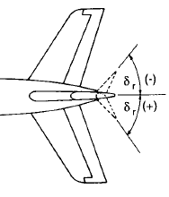
Yaw Control Using the Rudder-

We must be clear as to the sign convention related to the rudder.
For this reason, we include Figure 2.32 on p.77 at the right.
From this figure, we see that if the yaw angle $β$is positive, then
the rudder angle $δ_{r}$should be negative in order to right the plane.

Applying a negative $δ_{r}$will produce a negative$C_{L_{r}}=C_{L_{δ_{r}}}δ_{r}$. This
implies that the rudder lift derivative $C_{L_{δ_{r}}}>0$. Hence, the rudder
moment will be: Figure 2.32 of Nelson.

$C_{n_{r}}=−V_{v}η_{v}C_{L_{r}} = −V_{v}η_{v}C_{L_{δ_{r}}}δ_{r} \overset{Δ}{=} C_{n_{δ_{r}}}δ_{r}$. (45)
The rudder moment derivative $C_{n_{δ_{r}}}=−V_{v}η_{v}C_{L_{δ_{r}}}$ is referred to as the rudder control effectiveness.
The rudder lift derivative given in (2.86) on p.78 is:

$C_{L_{δ_{r}}}\overset{Δ}{=}\frac{{\text{dC}}_{L_{v}}}{{dδ}_{r}}=\frac{{\text{dC}}_{L_{v}}}{{dα}_{v}} \frac{{dα}_{v}}{{dδ}_{r}}\overset{Δ}{=}C_{L_{α_{v}}}τ$ (46)

where the parameter $\frac{{dα}_{v}}{{dδ}_{r}}\overset{Δ}{=}τ$can be estimated from Figure 2.21 on p.64. Using (40):
$\frac{{\text{dC}}_{L_{v}}}{dβ} = −C_{L_{α_{v}}}\left(1+\frac{∂σ}{∂β}\right) \overset{Δ}{=} C_{L_{β}}$ (40)
we can also write (46) as:
.
REMARK 1: From (43) and the leftmost equality in (45) we have: $\frac{C_{n_{β}}}{C_{L_{β}}}=\frac{C_{n_{δ_{r}}}}{C_{L_{δ_{r}}}}$. (47)
To prove that this result leads to the definition of $τ\overset{Δ}{=} \frac{{dα}_{v}}{{dδ}_{r}}$in (46). Suppose that (47) condition holds, and suppose that (46) holds:$C_{L_{δ_{r}}}=C_{L_{α_{v}}}τ$. We will prove that $τ= \frac{{dα}_{v}}{{dδ}_{r}}$.
Proof: $\frac{C_{n_{β}}}{C_{L_{β}}}=\frac{C_{n_{δ_{r}}}}{C_{L_{δ_{r}}}}=\frac{C_{n_{δ_{r}}}}{C_{L_{α_{v}}}τ} ⇒ τ=\left(\frac{C_{n_{δ_{r}}}}{C_{n_{β}}}\right) \left(\frac{C_{L_{β}}}{C_{L_{α_{v}}}}\right)=\left(\frac{{\text{dC}}_{n}{dδ}_{r}}{{\text{dC}}_{n}dβ}\right) \left(\frac{{\text{dC}}_{L}dβ}{{\text{dC}}_{L}{dα}_{v}}\right)=\left(\frac{dβ}{{dδ}_{r}}\right) \left(\frac{{dα}_{v}}{dβ}\right)=\frac{{dα}_{v}}{{dδ}_{r}}$ □

From the above proof, it follows that: $τ=\left(\frac{C_{n_{δ_{r}}}}{C_{n_{β}}}\right) \left(\frac{C_{L_{β}}}{C_{L_{α_{v}}}}\right)$. (48)

From (40), we have: $C_{L_{α_{v}}} = −C_{L_{β}}\left(1+\frac{∂σ}{∂β}\right)$. (49)

Substituting (48) into (49) gives: $τ = −\left(\frac{C_{n_{δ_{r}}}}{C_{n_{β}}}\right) \left(1+\frac{∂σ}{∂β}\right)$. (50)
If the sidewash derivative $∂σ/∂β$is known, then $τ$can be computed directly, as opposed to being estimated from Figure 2.21 on p.64. Notice that because $C_{n_{δ_{r}}}<0$ and $C_{n_{β}}>0$, it follows that $τ>0$.

From (50) we also have: $\frac{∂σ}{∂β} = −1+\left(\frac{τ C_{n_{β}}}{−C_{n_{δ_{r}}}}\right)$. (51)

Example 7. Find the permissible range of values for $∂σ/∂β$for the NAVION plane.
Solution: The derivatives given in Table B.1 on p.400 of Nelson are:

$C_{l_{β}}=−\text{.}{\text{074}}/{\text{rad}} ; C_{n_{β}}=−\text{.}{\text{071}}/{\text{rad}} ; C_{l_{δ_{r}}}=\text{.}{\text{107}}/{\text{rad}} ; C_{n_{δ_{r}}}=−\text{.}{\text{072}}/{\text{rad}}$.

Before proceeding any further, two points related to these values must be made:

Point 1: Since $C_{n_{β}}<0$corresponds to weathercock instability, there is a mistake. We will assume it is a simple sign error. Hence, $C_{n_{β}}=\text{.}\text{071}$.

Point 2: The parameters $C_{l_{β}}=−\text{.}{\text{074}}/{\text{rad}} ; C_{l_{δ_{r}}}=\text{.}{\text{107}}/{\text{rad}}$ are not the parameters $C_{L_{β}} ; C_{L_{δ_{r}}}$. They are roll moment derivatives associated with the side lift forces $L_{β}$and $L_{δ_{r}}$. As such, they are related to the vertical tail cg. This point illustrates the importance of notation. For example, on p.21 we have (1.64):

$L=C_{l}\text{QSl}$ Rolling moment.
Hence, $C_{l}$is a scaled moment. It then follows that, for example, $C_{l_{β}}={\text{dC}}_{l}dβ=C_{l_{β}}$.

From (51) we have: $\frac{∂σ}{∂β} = −1+\left(\frac{τ C_{n_{β}}}{−C_{n_{δ_{r}}}}\right) =−1+\left(\frac{\text{.}\text{071} τ}{\text{.}\text{107}}\right)=−1+\text{.}\text{66} τ$.
From Figure 2.21 on p.64 we observe that $0≤τ≤0\text{.}8$. Hence, $−1≤\frac{∂σ}{∂β}≤−0\text{.}\text{47}$. Notice that the sidewash gradient must be negative. This is consistent with the discussion following (42) above. □

Example 8. [Problem 2.13 on p.91 of Nelson] Size the vertical tail for the airplane configuration shown below so that its weathercock stability parameter,$C_{n_{β}}\text{=+}0\text{.}1/{\text{rad}}$. Assume $V=\text{150}m/s$at sea level.
$$S=\text{21}\text{.}3m^{2} ; b=\text{10}\text{.}4m ; z_{w}=0\text{.}4m ; d=1\text{.}6m ; l_{f}=\text{13}\text{.}7m ; x_{m}=8m ; w_{f}=1\text{.}6m ; S_{f_{s}}=\text{15}\text{.}4m ; h=h_{1}=1\text{.}6m; h_{2}=1\text{.}\text{07}m$$
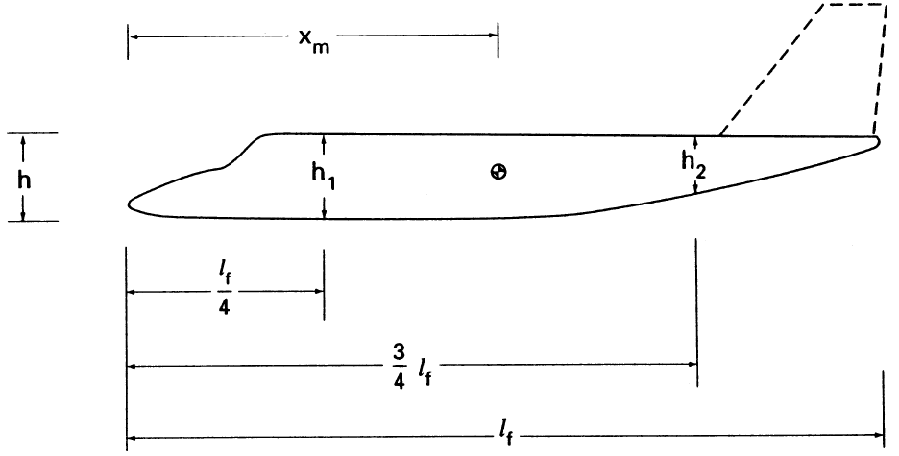

Solution: From (36) we have: $C_{n_{β_{\text{wb}}}}=−k_{n}k_{\text{Rl}}\frac{S_{\text{fs}}l_{f}}{Sb} (\text{/deg})$. We desire to have $C_{n_{β}}=0\text{.}1/{\text{rad}}=\text{.}\text{0017}/^{o}$.
From ${x_{m}}/{l_{f}}=8/{\text{13}}\text{.}7=0\text{.}\text{58}$and Figure 2.29 (red), we have $k_{n}≃\text{.}\text{0015}$. At sea level, $ν=1\text{.}\text{46}({\text{10}}^{−5}){m^{2}}/s$, and so $R_{l_{f}}=\text{141}({\text{10}}^{6})$. In relation to Figure 2.30, this gives $k_{\text{Rl}}≃2$. Hence,

$C_{n_{β_{\text{wb}}}}=−\frac{\text{.}\text{0015}(2)(\text{15}\text{.}4)(\text{13}\text{.}7)}{\text{21}\text{.}3(\text{10}\text{.}4)}=−\text{.}\text{0029}/^{o}=−\text{.}{\text{166}}/{\text{rad}}$.
Hence, the tail must contribute $C_{n_{β_{t}}}=C_{n_{β}}−C_{n_{β\text{wb}}}=0\text{.}1−(−\text{.}\text{166})=\text{.}{\text{266}}/{\text{rad}}$. And so, from (42):
$C_{n_{β_{t}}}=\text{.}\text{266}=V_{v}η_{v}C_{L_{α_{v}}}\left(1+\frac{dσ}{dβ}\right)$.

Now: $V_{v}=\frac{l_{v}S_{v}}{\text{Sb}}=\frac{l_{v}S_{v}}{\text{21}\text{.}3(\text{10}\text{.}4)}=\text{.}\text{0045} l_{v}S_{v}$. Also, from the ‘simple algebraic equation’ (44):
$η_{v}\left(1+\frac{dσ}{dβ}\right)=\text{.}\text{274}+3\text{.}\text{06} \frac{{S_{v}}/S}{1+\text{cos}Λ_{c/4w}}+\text{.}4 \frac{z_{w}}{d}+\text{.}\text{009} {\text{AR}}_{w}$,
where ${\text{AR}}_{w}={b^{2}}/S=\text{10}\text{.}{4^{2}}/{\text{21}}\text{.}3=5\text{.}\text{08}$, and where the maximum fuselage depth $d=h_{1}=1\text{.}6$. Hence,

$C_{n_{β_{t}}}=\text{.}\text{266}=(\text{.}\text{0045} l_{v}S_{v})C_{L_{α_{v}}}\left(\text{.}\text{274}+3\text{.}\text{06} \frac{S_{v}\text{21}\text{.}3}{1+\text{cos}Λ_{c/4w}}+\text{.}4 \frac{\text{.}4}{1\text{.}6}+\text{.}\text{009} (5\text{.}\text{08})\right)$, or

$\text{.}\text{266}=(\text{.}\text{0045} l_{v}S_{v})C_{L_{α_{v}}}\left(\text{.}\text{274}+\text{.}\text{1437} \frac{S_{v}}{1+\text{cos}Λ_{c/4w}}+\text{.}\text{1457}\right)$. (e7.1)

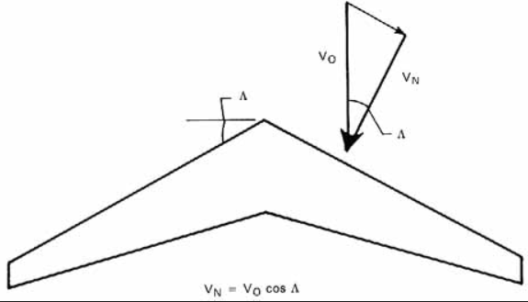
There are a number of parameters related to (e7.1) and (e7.2) that still are not known. In the solution manual of Nelson, it is now assumed that: $l_{v}=4m$and $C_{L_{α_{v}}}=0\text{.}1/^{o}=5\text{.}{\text{73}}/{\text{rad}}$. The solution makes no mention of an assumption of a value for $Λ_{c/{4_{w}}}$
Here, we will asume $Λ_{c/{4_{w}}}={\text{15}}^{o}=\text{.}\text{262}\text{rad}$.
Then (e7.1) becomes:

$\text{.}\text{266}=\text{.}\text{103}S_{v}\left(\text{.}\text{073}S_{v}+\text{.}\text{42}\right) ⇒ \text{.}\text{073}S_{v}^{2}+\text{.}\text{42}S_{v}−2\text{.}\text{58}=0 ⇒ S_{v_{1,2}}=−9\text{.}\text{48} , 3\text{.}\text{73}$. Hence, $S_{v}=3\text{.}\text{73} m^{2}$

[The author’s answer was $S_{v}=3\text{.}9m^{2}$; the difference due to his choice of a different value for $Λ_{c/{4_{w}}}$.] □

QUESTION: For the designed vertical tail, does the sidewash gradient have a stabilizing or destabilizing effect? In other words, does it make $C_{n_{β}}$larger or smaller?

ANSWER: $η_{v}\left(1+\frac{dσ}{dβ}\right)=\text{.}\text{274}+3\text{.}\text{06} \frac{3\text{.}9/{\text{21}}\text{.}3/S}{1+\text{cos}(\text{.}\text{262})}+\text{.}4 \frac{\text{.}4}{4}+\text{.}\text{009} (5\text{.}\text{08})=\text{.}\text{645}$. Hence, $\frac{dσ}{dβ}=\frac{\text{.}\text{645}}{η_{v}}−1$. In words, the sidewash gradient will b negative for $η_{v}={\left(\frac{V_{v}}{V_{w}}\right)}^{2}>\text{.}\text{645}$, or for $\frac{V_{v}}{V_{w}}>0\text{.}8$. It is hard to imagine that a speed ratio less than 0.8 is possible. Hence, we can conclude that the sidewash gradient is negative. Because it is negative, it reduces the yaw derivative, and so has a destabilizing effect per this metric. [Note: From (39): $C_{L_{v}}=−C_{L_{α_{v}}}α_{v}=C_{L_{α_{v}}}(β+σ)$and the fact that $σ=(∂σ/∂β) β$ with $∂σ/∂β<0$, we see that the amount of yaw is reduced when the sidewash angle is included. While this is a good thing, our definition of static stability is related to the moment needed to right the plane; not to the amount of yaw the plane is experiencing.]

2.3 Roll Stability [p.78 of Nelson]

On p.78 we have the following definition of static roll stability:

“An airplane posseses static roll stability if a restoring moment is developed when it is disturbed from a wings-level attitude.”

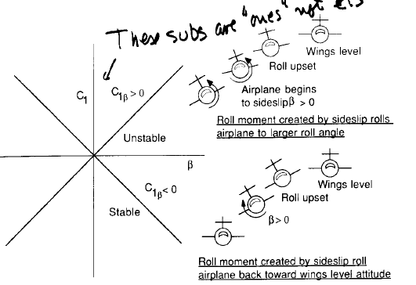
REMARK 3. The author then goes on to say: “The roll moment created on an airplane when it starts to sideslip depends on the wing dihedral, …”, and later, “When an airplane is disturbed from a wings-level attitude, it will begin to sideslip…”. These two statements suggest that, on the one hand, a small roll angle will generate sideslip that, in turn will generate more roll, while on the other hand, it is sideslip that generates the roll. If, for example, a lateral wind gust were to generate sideslip with the wing-level attitude maintained, would the plane begin to roll? I would suspect not. Now, one might argue that, in reality, there would always be at least a slight amount of roll generated by such a gust. And, in the case of a positive dihedral, this would be a positive roll. I can accept this explanation. However, I would then argue that it is the roll perturbation that is the origin of the roll, and that the attendant sideslip simply increases the roll once it has begun.

Nelson illustrates the development of roll in Figure 2.33 on
p.79 (shown at the right here). In this illustration only roll
is indicated. It may well be that the roll perturbation will
result in attendant sideslip. [I am by no means an expert in this
area, and so I would accept such a possibility.] [Notice that
in this figure the term $C_{1_{β}}$ is a typo. It should be $C_{l_{β}}$. This
figure is from Nelson’s first edition. It is corrected in the
second edition.]
Figure 2.33 on p.79.

Nelson then goes on to state, as well as illustrate in this figure, that “The requirement for (roll) stability is that $C_{l_{β}}<0$.” Unfortunately, he never gives an explicit expression for $C_{l_{β}}$. [As stated in Point 2 on p.18 of these notes, $C_{n_{β}}$is the yaw moment (about the vertical tail cg) derivative. ] From p.21 we have L=roll moment. Hence, C_{l} =L/(QSl). Hence, $C_{l_{β}}$= dCl/dβ. Nelson presumes the student is well aware of this notation. With this in mind, it should then be clear that for a perturbed positive roll, L, caused by side slip β, the restoring moment must be negative. In this event, we will have $C_{l_{β}}<0$.

The geometry associated with a roll angle $φ$is shown in Figure 2.34 on p.80:

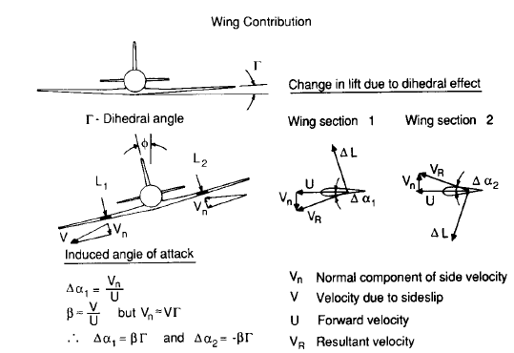
Figure 2.34 Influence of the dihedral $Γ$on the lateral velocity of each side of the wing for a roll angle $φ$.

The roll angle $φ$ differs from the angle of attack, $α$, and the sideslip angle, $β$, in that its reference is not the plane body coordinates, but rather the direction of gravity. In order to gain a better picture of exactly how $φ$relates to the roll moment derivative $C_{l_{β}}$, we will briefly digress from Nelson (where it is not clear at this point) to Etkin. However, we will begin this digression by recalling Figure 1.10 on p.20:
$\text{This} \text{is} L$

In the absence of any sideslip ($β=0$) and of any roll ($φ=0$), the velocity relative to the plane body coordinates is:

$V=V\left[\begin{matrix}\text{cos}α_{x} \\ 0 \\ \text{sin}α_{x}\end{matrix}\right]=\left[\begin{matrix}u \\ v \\ w\end{matrix}\right]$. (E3.11.1)
After rolling through an angle $φ>0$ about the body x-axis, it can be shown that the velocity becomes:

$V^{'}=V\left[\begin{matrix}1 & 0 & 0 \\ 0 & 0 & \text{sin}φ \\ 0 & 0 & \text{cos}φ\end{matrix}\right]\left[\begin{matrix}\text{cos}α_{x} \\ 0 \\ \text{sin}α_{x}\end{matrix}\right]=V\left[\begin{matrix}\text{cos}α_{x} \\ \text{sin}α_{x}\text{sin}φ \\ \text{sin}α_{x}\text{cos}φ\end{matrix}\right]=\left[\begin{matrix}u \\ v^{'} \\ w^{'}\end{matrix}\right]$. (E3.11.2)

Notice that the roll has not only reduced the velocity component w. It has also created a sideslip velocity $v^{'}=V\text{sin}α_{x}\text{sin}φ$! From equation (1.68) of Nelson, we have:
$β={\text{sin}}^{−1}\left(\frac{v^{'}}{V}\right)={\text{sin}}^{−1}(\text{sin}α_{x}\text{sin}φ)≃α_{x}\text{sin}φ≃α_{x}φ$. (E3.11.3)
The second rightmost approximate equality assumes small $α_{x}$. If, in addition, we assume that $φ$is also small, then we obtain the rightmost approximate equality. Equation (E3.11.3) is exactly the relation between $φ$and $β$ that Nelson omits.
As a result of this roll-induced positive sideslip,$β$, the plane will have roll static stability (i.e. positive roll stiffness) if the plane generates a negative roll moment. This roll moment is denoted as:

$C_{l}=C_{l_{β}}β=C_{l_{β}}α_{x}φ$. (E3.11.4a)

The roll moment derivative is: $C_{l_{φ}}=C_{l_{β}}α_{x}$. (E3.11.5b)

Hence, for static roll stability we must have $C_{l_{β}}<0$AND $α_{x}>0$.

Remark. The quantity $C_{l_{β}}$appears to be the roll moment derivative with respect to the sideslip angle, $β$. Indeed it is. However, the sideslip angle was generated by the roll angle $φ$. The chosen notation for $C_{l_{β}}$hides this fact.

For small sideslip this becomes: $β=v/u$. Because of the dihedral, the change in the angle of attack of the right (lower) wing is:
$Δα=\frac{v_{n}}{u}=\frac{v\text{sin}Γ}{u}≃\frac{vΓ}{u}=β Γ$ (56)

The change in the left (upper) wing angle of attack is simply the negative of (56).

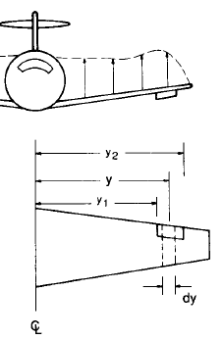
Roll Control-
Roll control is achieved by differential deflection of the ailerons. In relation
to Figure 2.36. consider an incremental lift, $Δ(y)$,at a location y along the
aileron. The corresponding rolling moment increment is:

$ΔL=Δ(y)×y = [C_{ℓ}Q(c \text{dy})]×y$. (57)
In (57) the parameter $C_{ℓ}$is the aileron section lift coefficient. For clarity,
we will rename this as $C_{L_{a}}$. Note that this is not the same ‘animal’
as $C_{L_{α}}$, which is a pitch lift derivative. Nor is it the roll moment coefficient Figure 2.36 on p.82
$C_{l}$ !!! Scaling (57) by
QSb gives: ${ΔC}_{l}=\frac{ΔL}{\text{QSb}} = \frac{C_{L_{a}}\text{cy} \text{dy}}{\text{Sb}}$. (58) We will now express the aileron lift coefficient $C_{L_{a}}$as: $C_{L_{a}}=C_{L_{α_{a}}}α_{a}$. (59)
From (59) we then have: $C_{L_{a}}=C_{L_{α_{a}}}α_{a}=C_{L_{α_{a}}}\left(\frac{α_{a}}{δ_{a}}\right) δ_{a} \overset{Δ}{=} C_{L_{α_{a}}}τ δ_{a}$. (60)
${ΔC}_{l}= \frac{(C_{L_{α_{a}}}τ δ_{α})\text{cy} \text{dy}}{\text{Sb}}$ (61)
If we multiply (61 ) by 2 in order to account for both ailerons, and integrate over the aileron span, we obtain:
$C_{l}= \frac{2C_{L_{α_{a}}}τ δ_{α}}{\text{Sb}}\int_{y_{1}}^{y_{2}}{\text{cy} \text{dy}}$. (62)
Hence: $C_{l_{δ_{a}}}= \frac{2C_{L_{α_{a}}}τ }{\text{Sb}}\int_{y_{1}}^{y_{2}}{\text{cy} \text{dy}}$. (63)

Notice in (63) Nelson uses the notation $C_{l_{α_{w}}}$instead of $C_{l_{α_{a}}}$, suggesting that this lift coefficient derivative is equal to the wing lift coefficient derivative. In view of this, the following explicit assumption should be stated: “We will assume that $C_{l_{α_{a}}}=C_{l_{α_{w}}}$”.

The Influence of the aileron width and position on the control power-

Recall that for a tapered wing: $c=c_{r}\left[1+\left(\frac{λ−1}{b/2}\right) y\right]$. (64)
From (64) we see that the wing tip chord length is a fraction, $λ$, of the the root chord length.

Hence, $\int_{y_{1}}^{y_{2}}{\text{cy} \text{dy}}= c_{r}\int_{y_{1}}^{y_{2}}{\left[1+\left(\frac{λ−1}{b/2}\right) y\right]y \text{dy}} = c_{r}{\left[\frac{y^{2}}{2}+\left(\frac{λ−1}{b/2}\right) \frac{y^{3}}{3}\right]}_{y_{1}}^{y_{2}}=\frac{c_{r}}{2}\left[\left(y_{2}^{2}−y_{1}^{2}\right)+\left(\frac{4}{3}\right)\left(\frac{λ−1}{b}\right) \left(y_{2}^{3}−y_{1}^{3}\right)\right]$. (65)
Now, it is easy to show that: $y_{2}^{2}−y_{1}^{2}=2Δ_{a}μ_{a}$ and $y_{2}^{3}−y_{1}^{3}=Δ_{a}(3μ_{a}^{2}+\text{.}\text{25} Δ_{a}^{2})$ (66)
where $Δ_{a}=y_{2}−y_{1}$is the aileron width, and $μ_{a}=\frac{y_{1}+y_{2}}{2}$is the position of the center of the aileron along the wing. Substituting (66) into (65) gives:
$\int_{y_{1}}^{y_{2}}{\text{cy} \text{dy}}=c_{r}Δ_{a}\left[μ_{a}−\left(\frac{1−λ}{b}\right) (2μ_{a}^{2}+\text{.}\text{167} Δ_{a}^{2})\right]$ . (67)
Substituting (67) into (63) gives:
$C_{l_{δ_{a}}}= \frac{2C_{L_{α_{a}}}τ c_{r}Δ_{a} }{\text{Sb}}\left[μ_{a}−\left(\frac{1−λ}{b}\right) (2μ_{a}^{2}+\text{.}\text{167} Δ_{a}^{2})\right]$. (68)

Special Case: Suppose that$2μ_{a}^{2}+\text{.}\text{167} Δ_{a}^{2}=2(μ_{a}^{2}+\text{.}\text{083} Δ_{a}^{2}) ≃2μ_{a}^{2}$. Then (68) becomes:

$C_{l_{δ_{a}}}≃ \frac{2C_{L_{α_{a}}}τ c_{r}Δ_{a}μ_{a} }{\text{Sb}}\left[1−\left(\frac{1−λ}{b/2}\right) μ_{a}\right]$. (69)
The moment derivative (68) is called the aileron roll control power. Equations (68) and its approximation, (69), give an explicit description of the influence of various key parameters on the control power. For example, as the term $\left(\frac{1−λ}{b}\right) 2μ_{a}=(1−λ)\left(\frac{μ_{a}}{b/2}\right)→1$ the control power goes to zero. Let ${μ_{a}}/(b/2)\overset{Δ}{=}r_{a}$ denote the ratio of the aileron center position to the half-wing span. Then $\left(\frac{1−λ}{b}\right) 2μ_{a}=(1−λ) r_{a}$. For this quantity to approach 1, we must have $λ→0$ and $r_{a}→1$. The first condition is physically possible, but the second is not for an ailerion with width $Δ>0$. Even so, we see clearly how $λ$ and $r_{a}$ influence the relative static roll stability.

The optimum aileron position-
$\frac{∂C_{l_{δ_{a}}}}{∂μ_{a}}=0=1−\left(\frac{1−λ}{b}\right) 4μ_{a} ⇒ μ_{a}^{\text{opt}}=\frac{b/2}{2(1−λ)}$. For $λ=0\text{.}5$, $μ_{a}^{\text{opt}}=b/2$, which implies that the center should be as near to the tip as possible. For$λ=0\text{.}\text{25}$, $μ_{a}^{\text{opt}}=b/3$. □

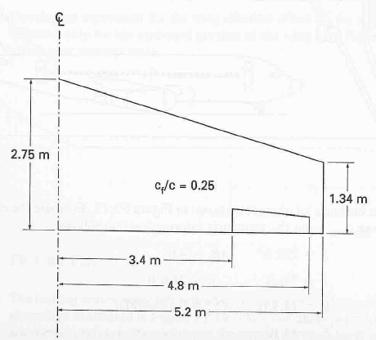
Example 9 [Problem 2.14 on p.91 of Nelson]
Figure P2.14 shows the wing planform for an aivation business
airplane. Determine the roll control power. [Assume that the
aileron section lift coefficient is $C_{L_{α_{a}}}^{∞}=0\text{.}1/^{o}$.
Solution:
Step 1: $S=\text{21}\text{.}3m^{2}$ and $\text{AR}=\frac{b^{2}}{S}=5\text{.}\text{08}$. Hence,
$$C_{L_{α_{a}}}=\frac{C_{L_{α_{a}}}^{∞}}{1+C_{L_{α_{w}}}^{∞}(π \text{AR})}=\frac{5\text{.}\text{75}}{1+5\text{.}{\text{73}}/(π∗5\text{.}\text{08})}=4\text{.}{\text{21}}/{\text{rad}}$$

Step 2: Using ${c_{a}}/c=\text{.}\text{25}$in Figure 2.20 gives $τ=0\text{.}\text{48}$

Step 3: $λ=\frac{1\text{.}\text{34}}{2\text{.}\text{75}}=\text{.}\text{487}$. $Δ_{a}=4\text{.}8−3\text{.}4=1\text{.}4$. $μ_{a}=\frac{4\text{.}8+3\text{.}4}{2}=4\text{.}4$.

Step 4: $C_{l_{δ_{a}}}= \frac{2C_{L_{α_{a}}}τ c_{r}Δ_{a} }{\text{Sb}}\left[μ_{a}−\left(\frac{1−λ}{b}\right) (2μ_{a}^{2}+\text{.}\text{167} Δ_{a}^{2})\right]=0\text{.}{\text{17}}/{\text{rad}}$. □

