EXAM 3 AERE355 Fall 2019 (Take-Home) Due 12/13(F) Name_____________________________________

PROBLEM 1(45pts) This problem addresses the influence of the cg on the roots of the approximate short period mode characteristic polynomial in relation to the NAVION plane.

(a)(10pts) In EXAMPLE PROBLEM 2.2 on pp.57-61 the authors arrive at a number of values for various parameters. Here, we will assume that the following values given in Table B.1 on p.400 are correct:
. (1)
(i)The authors claim that . Identify the appropriate very simple relation in TABLE 3.3 on p.116 that, along with (1), validates this claim.
Solution:

(ii) At the top of p.58 the authors claim that . Using , along with the appropriate geometry information in the example, to show that this is incorrect.
Solution:

(iii) The authors claim that . Assuming that , use , the appropriate information in the example, and the appropriate expression in TABLE 3.3, validate this claim. [Note: Use your value in (i) above.]
Solution:

(b)(9pts) We will now consider the range of normalized cgs: , where As the cg is moved aft, the normalized length to the tail AC will become smaller. Specifically: . The expression for associated with a given is given on p.56 as:
. (2.36).
Arrive at a plot of versus h.
Solution: [See code @ 1(b).]
Figure 1(b) Plot of versus h.

(c)(15pts) Arrive at a plot of the root locus associated with
for varying h.
Solution: [See code @ 1(c).]

Figure 1(c) Root locus plot of for .

(d)(5pts) In (b) you should find that . In words, for this index 147, the plane has neutral static stability. In (c) you should find that for this index the roots of are and . Hence, even though the plane is neutrally statically stable, it is locally dynamically stable. Suppose that for this situation, the plane were given a brief perturbation moment that caused the static angle of attack to change by an amount . Ignoring the root give a sketch of how the angle of attack would evolve over time. In doing so, give approximate values on the time axis.
Solution: Figure 4(d) Sketch of .

(e)(6pts) From your root locus plot in (c) you should find that at the roots change from a complex conjugate pair to repeated real roots. Furthermore, as h increases to the conjugate roots move in an essentially vertical manner as they head toward the real axis. Explain how the dynamic parameters are changing during this movement.
Explanation:

PROBLEM 2(25pts) This problem addresses a research topic that is receiving renewed attention in recent years. It relates to vortex shedding turbulence off the trailing edge of an airfoil, as shown in Figure 3 below; taken from
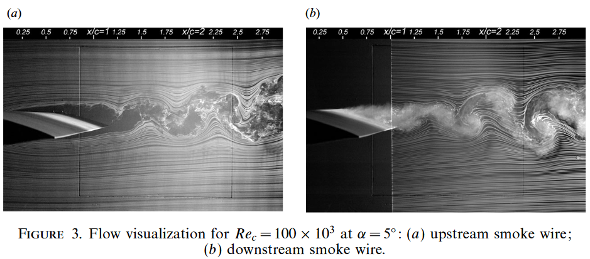
http://citeseerx.ist.psu.edu/viewdoc/download?doi=10.1.1.569.7015&rep=rep1&type=pdf . The article was published in J. Fluid Mech.(2009),vol.632,pp.245–271.

As can be seen from plate (b), the turbulence off the trailing edge is of an oscillating nature. This can lead to flapping of the trailing edge, as well as to oscillatory downwash. In this problem we will arrive at a model to simulate such turbulence.

(a)(5pts) To accommodate the oscillating nature of the turbulence, consider the shaping filter: .
Use the Matlab ‘integral’ command to find the value of c so that . Give ALL of your code HERE.
Solution:

(b)(10pts) Regardless of your answer in (a), assume here that . Suppose that we require that the turbulence have power . Arrive at the turbulence power spectral density plot.
NOTE: Use w=logspace(0,2,5000) and give in dB.
Solution: [See code @ 2(b).]

Figure 2(b) Plot of .

(c)(10pts) If we assume a Nyquist frequency , the corresponding sampling period is . Obtain a simulation of the turbulence over a 200-second window. Then discuss whether or not you believe the amplitudes are reasonable.
Solution: [See code @ 2(c).]

Figure 2(c) Plot of simulated turbulence.

PROBLEM 3(30pts) This problem addresses some basic concepts related to feedback control.

(a)(8pts) The authors introduce the concept of a stability augmentation system (SAS) on p.313. From the third equation on p.313 we have the following transfer function between the input and the output :
. (1a)
The portion of the block diagram in FIGURE 8.29 that is enclosed in the dashed box is shown at right. Beginning with (1a), carry out ALL steps to show that
. (2a)
Solution:

(b)(5pts) Find the value of k such that the time constant associated with (2a) is 1/10th of that associated with (1a).
Solution:

(c)(7pts) Regardless of your answer in (b), assume here that . Overlay the unit step responses of derived from (1a), and (2a). Then use it directly to validate your design.
Solution: [See code @ 3(c).]

Figure 3(c) Unit step responses.

(d)(5pts) Let the rate gyro feedback control system plotted in (c) be
denoted as . Then the entire closed loop negative feedback control system is shown at right. The forward
loop transfer function is , and the feedback loop transfer function is . The entire closed loop transfer function is . Suppose that . Find the value of K so that the closed loop static gain is 0.95.
Solution:

(e)(5pts) Regardless of your answer in (d), use here in order to arrive at the unit step response of entire closed loop system . Then explain whether it is acceptable or not. In particular, does it achieve the desired steady state value? Are its dynamics similar to those of the rate gyro closed loop system?
Solution: [See code @3(e).]

Figure 3(e) Closed low system unit step response.

Appendix Matlab Code
%PROGRAM NAME: exam2.m 10/25/19
%PROBLEM 1
%(b):

%(c):

%=======================================
%PROBLEM 2
%(a): G(s)=1/(s^2+0.2s+100)

%(b):

%(c):

%===============================
%PROBLEM 3
%(c):

%(d):

%(e):

