- Laplace and Z Transforms
- Laplace Properties
- Z Xform Properties

Table of Laplace and Z Transforms
(Please email me if you find an error)
Using this table for Z Transforms with Discrete Indices
Shortened 2-page pdf of Laplace Transforms and Properties
Entry  # | Laplace Domain | Time Domain | Z Domain  (t=kT)
1
2 |  |  | 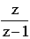
3 |  |  | 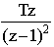
4 | 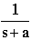 |  | 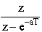
5 |  | 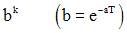 | 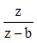
6 | 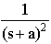 |  | 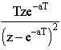
7 | 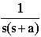 | 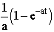 | 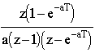
8 | 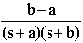 |  | 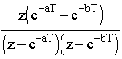
9 | 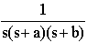 | 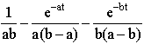
10 | 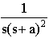 | 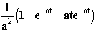
11 | 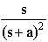
12 | 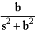 |  | 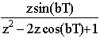
13 | 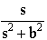 |  | 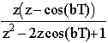
14 | 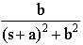 |  | 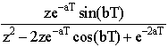
15 | 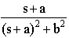 |  | 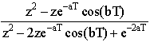
16 | 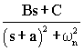 | 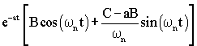  Bad notation. Better to use ω_{d}.
17 | ??? | 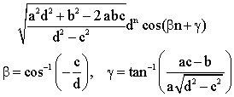 | 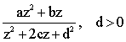
Prototype Second Order System (ζ<1, underdamped)
18 | 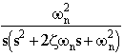 | 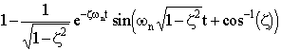
19 | 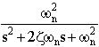 | 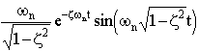
20 | 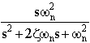 | 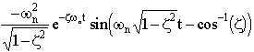

Using this table for Z Transforms with discrete indices
Commonly the "time domain" function is given in terms of a discrete index, k, rather than time. This is easily accommodated by the table. For example if you are given a function:
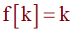
Since t=kT, simply replace k in the function definition by k=t/T. So, in this case,
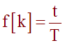
and we can use the table entry for the ramp
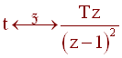
The answer is then easily obtained
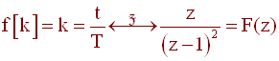

© Copyright 2005-2007 Erik Cheever This page may be freely used for educational purposes.
Comments? Questions? Suggestions? Corrections?
Erik Cheever Department of Engineering Swarthmore College
