Rolling Element Bearings

Hydrodynamic bearings are bearings where an oil-film separates metal to metal contact between the bearing and the shaft.

Used for high rotational speeds and momentary overloads and impact.

Rolling element bearings are bearings where balls or rollers are “sandwiched” between two rings or races; one race—the inner race houses the shaft.

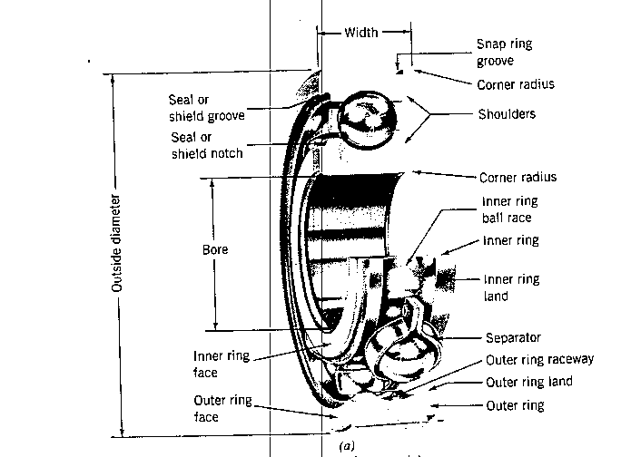

Rolling element bearings are good for applications with high starting loads—rail car axles on a locomotive, for example. Starting friction is relatively low.

Rolling element bearings are typically “nosier” than hydrodynamic bearings.

The two types of rolling element bearings:

- Ball bearings
- Roller bearings

Ball bearings can handle higher speeds, while roller bearings can handle higher loads.

Rolling element bearings are classed according to the types of loads they can carry:

- Radial (directed along the radius)
- Thrust or Axial (directed along the longitudinal axis of the shaft)
- Angular contact (radial + axial)

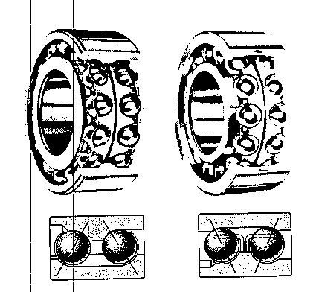
Double Row
Angular Contact

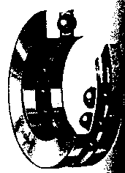

Thrust

Assembly of Deep Groove (Conrad type) ball bearings

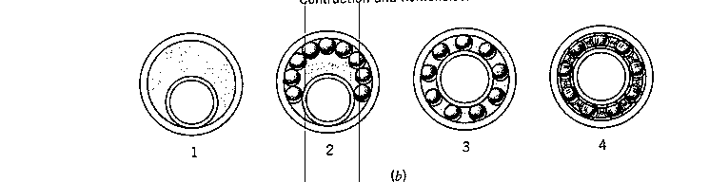

If filling notches are added, more balls can be pushed in and greater loads can be handled (20-40% increase in radial load capacity—but thrust load capacity is greatly reduced and sensitivity to misalignment is increased).

Roller bearings are classified by their roller configuration

- Cylindrical
- Spherical
- Tapered
- Needle
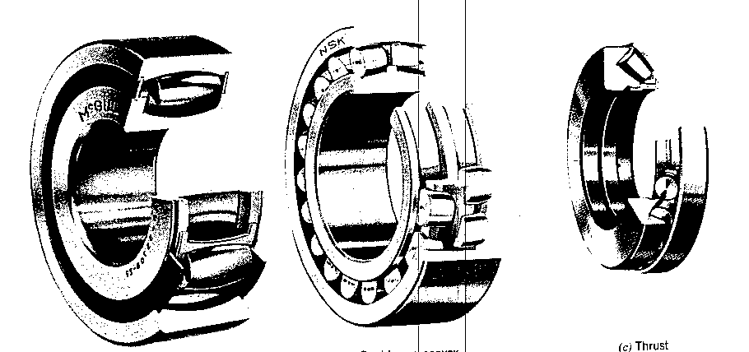

Spherical Roller Bearings

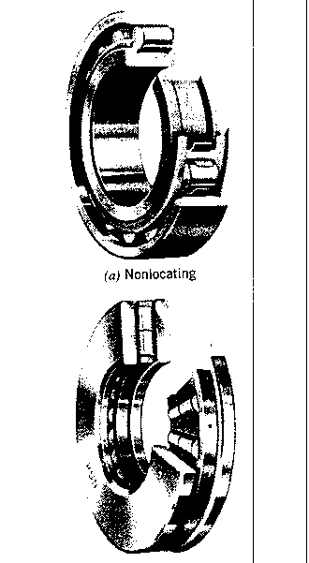
Cylindrical Roller Bearings

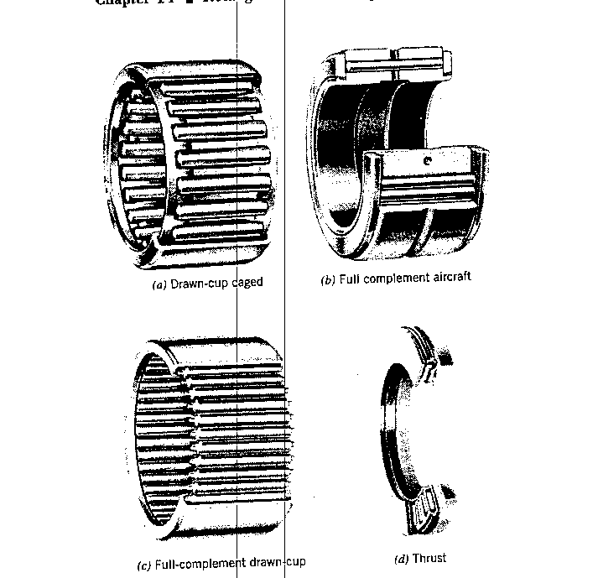

Needle Bearings
Good at increasing radial space.

Bearing Design

The trick is to maximize contact area to carry load, but minimize sliding and friction.

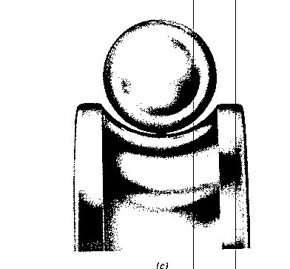

Studying stresses on bearings requires understanding how the ball contacts the races (surface patch contact). Elastic deflection of the ball due to loading, makes the patch area difficult to analyze. Deflection increases contact area (carry bigger loads), but increases sliding and friction.

Inner raceway radius of curvature is slightly larger than the radius of
the ball
Outer raceway radius of curvature is larger than the radius of curvature of the inner raceway

Bearing Selection

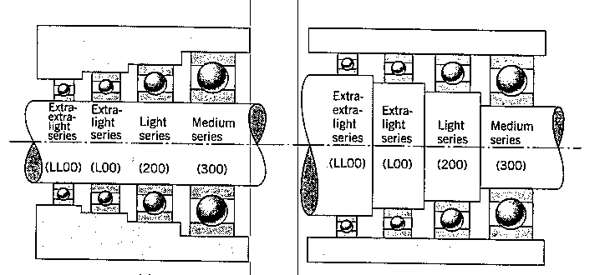

Bore is same size O.D. of bearings is same size

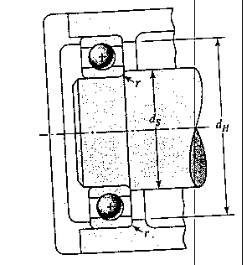

Vendor information

Bearing Basic Number

Series—multiply last 2 digits by 5 to get bore diameter

L08 – Extra light series – 40 mm bore
316 - Medium series – 80 mm bore

Bore diameter
Outside diameter
Width of race, w
Corner radius, r
Shaft diameter, ds
Housing diameter, dh

Your choice of bearing will also require you to understand:

Basic Load Rating, lubrication requirements, precision, and closure (sealed, shielded) and sometimes, static load capacity.

Assignment:

Visit Timken’s web site (www.timken.com) and look at the information they provide for ball and roller bearings.

Basic Load Ratings (how do they define it?)
Static Load Capacity (how do they define it?)

As an engineer looking for a ball bearing –what types of information do you need to go to Timken with to pick out a bearing?

As an engineer looking for a roller bearing---what types of information do you need to go to Timken with to pick out a bearing?

