SCHOLARS GUIDE FOR CHINA SCHOLARSHIP COUNCIL GRADUATE STUDENTS AND
DIRECTORS OF GRADUATE EDUCATION AND STAFFS
IOWA STATE UNIVERSITY

Description of the program:
The China Scholarship Council (CSC) and Iowa State University have signed an agreement of cooperation to provide a platform for selection and funding of excellent Chinese students to enroll at ISU and pursue doctoral degrees. If the selected Chinese students successfully complete the requirements of the designated program and successfully defend their dissertation, they will be conferred doctoral degrees by ISU.

Selection Criteria:
Candidates will meet the normal selection criteria for the graduate program at ISU set forth by the individual programs which include, but are not limited to: academic preparation, English proficiency and GRE general aptitude. Candidates will also satisfy the selection requirements and criteria set out by CSC.

Application Process:
- Candidates should directly apply for admission to ISU in accordance with the requirements and procedure set out by ISU (http://www.iastate.edu). Candidates should specify in their application they are applying for the CSC/ISU Joint Scholarship Program.
- ISU will evaluate the candidates, and decide which candidates are admissible to its programs. By March 1 of each year, ISU will provide CSC and each qualified candidate with a copy of an offer letter. Offer letters will be unconditional in terms of academic performance and English language capability and should specify that ISU will provide each candidate with funding equivalent to the cost of tuition under the condition that the CSC's support is secured. The deadline for CSC's application is March 20 of each year.
- Usually, the student in collaboration with proposed major professor or DOGE prepares a research plan that will be part of the application package to CSC.
- After receiving an offer letter from ISU and the jointly prepared research plan, candidates must apply to CSC in accordance with the regulations and procedures set out by CSC (http://www.csc.edu.cn).

CSC will evaluate the candidates and provide ISU with a final list of scholarship recipients and inform the successful candidates in early May. The chosen candidates must then register as an ISU doctoral student. Individual programs at ISU are then notified by the applicants themselves whether they received scholarship or not.

Eligibility criteria:

Only a select number of Chinese University students in certain fields are eligible to apply. Initially, only 39 universities were selected by CSC, and this list has been expanded to 60 with a broader coverage of the fields and geographic areas. The following is the list of Chinese universities that are eligible for CSC scholarship as of 2013.

Peking University

Tsinghua University

Harbin Institute of Technology

Zhejiang University

Xian Jiatong University

Nanjing University

University of Science and Technology of China

Shanghai University

Fudan University

Northwest Agricultural and Forestry University

Beijing Normal University

China Agricultural University

Shandong University

Tongji University

Southeast University

Jilin University

Northwest Polytechnical University*

Sichuan University

East China Normal University

Dalian University of Technology

Wuhan University

Tianjin University

Central Southern University

Chongqing University

Huazhong University of Science and Technology

Nankai University

Sun Yat-sen University

Beihang University

Xiamen University

Beijing Institute of Technology

Lanzhou University

Renmin University of China

Ocean University of China

National University of Defense Technology*

University of Electronic Science and Technology of China

South China University of Technology

Northeast University

Hunan University

Minzu University of China

Beijing University of Posts and Telecomunications

Central University of Finance and Economics

University of Science and Technology of Beijing

Shanghai University of Finance and Economics

China University of Mining and Technology

China University of Geosciences (Wuhan)

China University of Geosciences (Beijing)

China University of Mining and Technology (Beijing)

China University of Petroleum (Beijing)

China University of Petroleum (Huadong)

Hohai University

China University of Political Science and Law

Sichuan Agricultural University

Beijing Jiatong University

East China University of Science and Technology

Shanghai University

Wuhan University of Technology

Southwest University

Huazhong Normal University

Nanjing Agricultural University

Beijing Forestry University

Number of Candidates: CSC and ISU agree that up to 20 jointly sponsored students per year under this agreement may be funded. In the past, the number of candidates has been less than 10 per year and only a fraction of them actually registered and matriculated to the programs at ISU.

  - Funding model: For successful applicants, ISU will provide funding equivalent to the cost of tuition. CSC will consider the applications of those receiving these ISU awards for living allowances for up to 48 months with the standard prescribed by the Chinese Government (which includes student health insurance), a "round trip" airfare to Des Moines by the most economical route and visa application fees. Successful candidates are expected to return to China upon completion of their studies and/or research.

  - Application and Admission Process:
Eligible applicants (students from approved universities either in their last year of undergraduate degree, or M.Sc. students who meet the CSC eligibility requirement) will apply directly to ISU as any other international applicant. The applicant indicates in his/her application that s/he is eligible to CSC and intends to apply for CSC Graduate scholarship if s/he is admitted to ISU. Relevant graduate program evaluates the candidate according to its set standards for any international student applicant and offers a conditional admission with an official letter stating that student is accepted to the Ph.D. program (or in some fields to Masters degree) and will be awarded tuition scholarship provided the applicant receives a CSC scholarship for doctoral degree (or Masters) at ISU. A sample of “conditional admission letter” adopted from the mechanical engineering program is included at the end of this document. Once the student informs the graduate program that s/he has been granted the CSC scholarship, the admission will be official and the program will initiate request for Status for Externally Funded Graduate Student.

- University Policy on CSC scholar tuition scholarship:
The CSC scholar is classified as an externally funded graduate assistant and thus for purposes of tuition assessment s/he is treated as a graduate assistant (C-base). CSC Scholars receive full tuition scholarships from Iowa State University. According to university policies, programs that directly fund graduate students and that are highly selective may be considered for “externally funded graduate assistant” status. Such programs are often funded and administered by governments or international foundations. Typically a formal agreement is in place with the funding organization that specifies the selection process and funding level for graduate stipends. The CSC program has been reviewed and approved for externally funded graduate assistant status. It is then the responsibility of the student’s college (potentially in collaboration with the home department and/or major professor) to provide a scholarship equivalent to resident tuition so that the student will be relieved from tuition burden.

The terms and conditions of the CSC tuition scholarship are in part cited above in the Application Process, and Funding Model sections of this document. Briefly, Iowa State University will offer tuition scholarships to CSC candidates provided that these students secure a scholarship from CSC in the form of stipend (living expenses, health insurance and other miscellaneous expenditures) for up to 48 months and the student makes acceptable progress toward the sought degree. Of course, if the CSC scholar fails to maintain satisfactory student status, the university reserves the right to terminate the student and tuition scholarship.

Frequently asked questions:
Q. What if the student is conditionally admitted but does not get the CSC scholarship?
A. The admitting program could still admit the student by offering assistantship. This of course, means the department/program also assumes full responsibility of in-state tuition that will be assessed. Alternatively, the student is admitted as self-supporting. In this case, the student is responsible for all the expenses including non-resident tuition.

Q. What if the student is admitted to ISU and receives CSC scholarship but changes his/her mind to study at another school?
A. That is unlikely. The student is given a CSC scholarship based on the application s/he submits to CSC with specific university and research plan.

Q. What are the criteria CSC uses to offer scholarship?
A. This is not very clear and it may be changing year-to-year. In addition to the qualifications of the student (TOEFL, GRE, GPA, rank in graduating class, etc.), the ranking of the institution, program, reputation and rank of the proposed major professor, quality of the research plan statement, and the home institution of the student will all be considered.

Q. Who pays for the in-state tuition of the student?
A. It is up to individual colleges to decide. In engineering and liberal arts and sciences, the colleges will pay one-half of the in-state tuition. The other half will be paid the department or major professor.

Q. Can the tuition share of the major professor be paid from a federally funded project?
A. That depends on the agency and type of funding. Certain agencies do not allow funding tuition unless the student is paid a stipend for the research from that particular project. In this case, the proposed major professor, DOGE and the department chair will identify alternate sources.

Q. Can a program or major professor supplement the CSC scholarship stipend?
A. Under certain conditions, supplemental stipend is allowed. The university guideline on this topic is included as a supplement to this document.

Q. Where can I find additional information?
China Scholarship Council (CSC).
http://www.csc.edu.cn/edufair/default.aspx

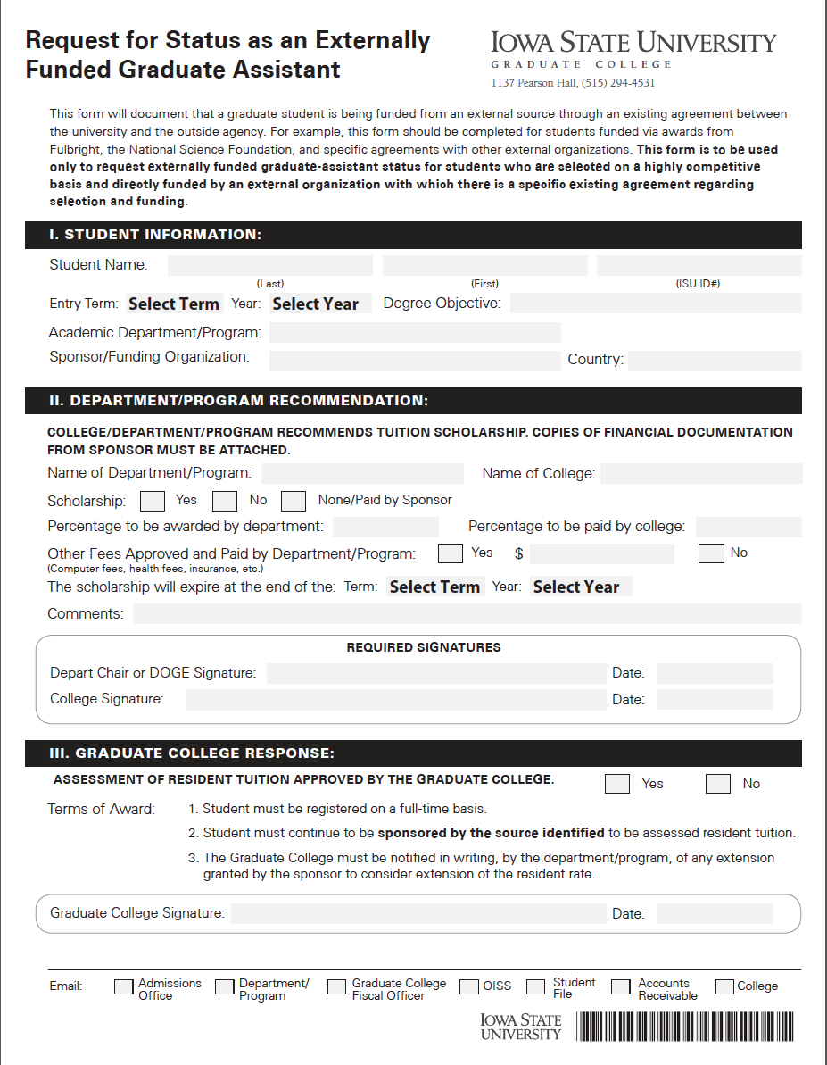

SAMPLE
CONDITIONAL ADMISSION LETTER

Dear {NAME}:

Congratulations on your conditional admission to the PhD program in { name of the Graduate Program} Engineering for the {Semester and year}! Based on the strength of your academic performance, we will recommend your admission into the Ph.D. program in {Name of the Graduate Program}.

In addition to providing you with an opportunity to earn a Ph.D. degree in {name of the graduate program}, we are also offering you a scholarship which will cover your tuition provided that you make satisfactory progress toward your Ph.D. degree as determined by the {name of the graduate program}, and you continue to receive Chinese Scholarship Council (CSC) doctoral scholarship while at ISU. The details of tuition scholarship along with other important information to help you become a part of our graduate program are detailed below. We sincerely hope you accept our offer and join us at Iowa State for your graduate study!

Scholarship
As part of this offer, you will also be offered a scholarship that will cover the graduate student tuition. All tuition scholarships are contingent upon satisfactory progress toward completing your degree and your appointment as China Scholarship Council (CSC) scholars. You will be responsible for paying the university fees of approximately $445 per semester. If you have inquiries about the scholarship and conditions, please contact {DOGE’s name}, at {DOGE’s e-mail address} or by phone at {phone number}.

Major Professor
As part of our graduate program, each student has a major professor who guides him/her through his/her studies. After your formal application, you will have the opportunity to interact with our faculty and decide upon a major professor who will guide you during your graduate study. If you have any immediate inquiries about your plans for graduate study, you can contact {DOGE’s name} by e-mail at {DOGE’s e-mail address}. Attached is a listing of faculty involved in our graduate research programs. We encourage you to review the expertise of the faculty by viewing their research interests at {department’s website address}.

Your decision
Please let us know whether you are accepting the conditional admission offer as soon as possible. You will have to complete the graduate application for fall {year} admissions through the website (http://www.admissions.iastate.edu/apply/graduate.php) as soon as possible but no later than {Deadline}.

Graduate study is a challenging and rewarding experience, and your qualifications indicate that you would find our outstanding students and faculty a stimulating group of colleagues. I look forward to seeing you on campus next fall semester. If I may be of assistance, please do not hesitate to contact me.

Sincerely,

{DOGE’s name}
Director of Graduate Education
{Name of the Graduate Program}
encl. List of faculty members involved in graduate education

Chinese Scholarship Council Ph.D. Supplemental Funding Guidelines
(October 7, 2013)
Background
The Chinese Scholarship Council program provides funding for PhD students to pursue Ph.D. degrees at ISU, as well as other universities. The funding is provided on a selective basis, to students who are expected to complete the requirements for the Ph.D. in a reasonably short period time. As a result, it is a CSC expectation that scholars not be appointed to graduate assistantships that could delay their progress or degree completion. Unfortunately, it is not unusual for the stipends provided to scholars to be below the minimum expected half-time graduate stipend at ISU. These guidelines are intended to provide a framework for supplementing scholar stipends via mechanisms that are unlikely to delay degree completion.

Potential Supplemental Funding Mechanisms
- It is appropriate, when possible, to provide supplemental funding to CSC scholars as scholarships that are in addition to their full tuition scholarships.
- It is appropriate to appoint CSC scholars as up to ¼-time graduate research assistants if their RA appointment responsibilities are directly related to their dissertation research.
- It is not appropriate to appoint CSC scholars as graduate administrative assistants or graduate teaching assistants.
- It is not appropriate to appoint CSC scholars as hourly employees.
- All CSC scholars are categorized as externally funded graduate assistants and are thus assessed resident tuition and receive full tuition scholarships as Ph.D. students, regardless of whether or not they are provided supplemental funding.
- Academic colleges may have policies restricting the types of supplemental funding that are allowed for CSC scholars, but it is expected that such policies will still enable reasonable supplemental funding to be provided to CSC scholars with stipends that are lower that ISU expected minimums.
Iowa State University College of Engineering Guidelines for Supplemental Funding
SUPPLEMENTAL FUNDING GUIDLEINES FOR CSC SCHOLARS

ISU has an agreement with the China Scholarship Council (CSC) that provides opportunities to top Chinese graduates to pursue advanced degree at Iowa State University (ISU). The CSC awardees are provided by a scholarship by the Chinese government that includes a stipend (up to 48 months), international health insurance, round trip plane ticket, and expenses for book purchases. In addition, ISU provides tuition scholarship for the awardees as long as they receive CSC scholarship and making adequate progress toward their respective degrees.

The stipend level is determined by the CSC for each location presumably depending on the cost of living for a particular site. Although the stipend provided by the CSC is deemed to be adequate for living expenses, it is often lower than the stipend offered by the individual departments at ISU.

In order to prevent hardship that student may experience and to even out the differences between the stipend offered by ISU and CSC, individual departments, at their discretion and depending on the availability of funds, may provide supplemental funding in the form of scholarship in an amount such that total scholarship amount (CSC and ISU) must not to exceed the departmental stipend offered to its graduate students. Student must provide formal CSC offer letter spelling out the stipend amount and other benefits. Funding source for the supplemental scholarship is expected to come from either the major professor or departmental funds.

